University of Macau
Faculty of Science and Technology

Single Domain Generalized Medical Image Analysis
by
CHENHONGDA DC229862
Graduation Project Report submitted in partial fulfillment
of the requirements of the Degree of
Bachelor of Science in Computer Science
Project Supervisor
Prof. Long CHEN
12 May 2026
DECLARATION
I sincerely declare that:
- I and my teammates are the sole authors of this report,
- All the information contained in this report is certain and correct to the best of my knowledge,
- I declare that the thesis here submitted is original except for the source materials explicitly acknowledged and that this thesis or parts of this thesis have not been previously submitted for the same degree or for a different degree, and
- I also acknowledge that I am aware of the Rules on Handling Student Academic Dishonesty and the Regulations of the Student Discipline of the University of Macau.

Signature : 

Name : CHEN HONGDA

Student No. : DC229862

Date : 12 May 2026

ACKNOWLEDGEMENTS
I would like to express my utmost gratitude to the University of Macau for providing the opportunity to carry out this project as a partial fulfillment of the requirements for the degree of Bachelor of Science in Computer Science.
This project lasted from September last year to the present, covering multiple stages including model debugging, training, and evaluation. I am deeply grateful to my supervisor, Professor Chen Long, for his continuous guidance, valuable suggestions, and encouragement throughout the entire research process. Monthly meetings with Professor Chen provided clear direction and helped me overcome numerous technical challenges.
I also wish to thank my teammate, Mr. Wang Yufeng, for the collaborative effort on this project. Together, we worked on model implementation, data preprocessing, experiment execution, and result analysis. The teamwork and mutual support greatly contributed to the completion of this work.
Finally, I acknowledge the support of the academic and technical staff at the Department of Computer Science for providing necessary resources and a conducive research environment.
Looking back at my four years at the University of Macau, I left my hometown and came to a completely unfamiliar environment. I have experienced a great deal and met people from all over the world. I would like to thank everyone who has crossed my path during these four years – whether through setbacks or achievements, all of these experiences have directly brought me to where I am today. I will cherish my time in Macau; it was a period of growing up, independent and sometimes lonely, but truly invaluable.

ABSTRACT
Deep learning models for medical image analysis often suffer from performance degradation when tested on data from different domains (e.g., different hospitals, scanners, or patient populations) due to domain shift. Single Domain Generalization (SDG) aims to train a model using data from only one source domain that can generalise well to unseen target domains. Among various SDG techniques, data augmentation is the simplest and most effective approach, as it artificially expands the diversity of the training domain without requiring additional data collection.
Data augmentation is essential in medical imaging for improving classification accuracy, lesion detection, and organ segmentation under limited data conditions. However, two significant challenges remain. First, a pronounced domain gap between natural photographs and medical images can distort critical disease features. Second, augmentation studies in medical imaging are fragmented and limited to single tasks or architectures, leaving the benefits of advanced mix-based strategies unclear.
This study systematically evaluates three data augmentation methods – Noise injection, SalfMix (saliency-based region mixing), and Elastic transformation – on two medical image datasets (brain tumour MRI and ocular disease fundus) using two backbone networks (ResNet-50 and ViT-B). All models were trained on a Google Colab T4 GPU (50 epochs for ViT-B, 1 epoch for ResNet-50), and performance was measured using accuracy, F1 score, and ROC AUC.
The experimental results show that Noise augmentation is the most versatile method, achieving the best overall performance for ViT-B on both datasets and for ResNet-50 on the ocular disease dataset. SalfMix achieves the highest ROC AUC (98.16%) on the brain tumour dataset with ViT-B, demonstrating its strength in fine-grained classification of visually similar classes. Elastic transformation performs best for ResNet-50 on the brain tumour dataset (80.75% accuracy) but suffers from low recall (62.28%), indicating a trade-off. ViT-B consistently outperforms ResNet-50 across all settings, with accuracy gains of 10–18%, suggesting that global self-attention is particularly beneficial for medical images with complex spatial structures.

TABLE OF CONTENTS
CHAPTER 1. INTRODUCTION 8
1.1 Research Background and Significance 8
1.2 Existing Problems 9
1.3 Research content of this paper 9
1.4 Thesis structure 10
CHAPTER 2. RELATED WORK 13
2.1 Deep Learning in Medical Image Classification 13
2.2 Overview of Data Augmentation Methods 13
CHAPTER 3. METHODOLOGY 18
3.1 Overall Framework 18
3.2 Dataset Description 20
3.3 Three Image Augmentation Methods 21
3.4 Backbone Networks 24
3.5 Training Setup 25
CHAPTER 4. EXPERIMENTAL DESIGN AND RESULTS 29
4.1 Experimental Setup 29
4.2 Results on Brain Tumor Dataset 29
4.3 Results on Ocular Disease Dataset 31
4.4 Visualization Analysis 33
4.5 Results Comparison and Discussion 37
Chapter 5. Ablation Study and Discussion 39
5.1 Impact of Augmentation Parameters 39
5.2 Model Robustness Analysis 39
5.3 Training Efficiency Analysis 40
CHAPTER 6. CONCLUSION 42
6.1 Summary of Findings 42
6.2 The Use of AI 42
6.3 Ethics and Professional Conduct 43
REFERANCES 45
APPENDIX 47

LIST OF FIGURES
Figure 1. Brain Tumor MRI Dataset Distribution 20
Figure 2. Eye Disease Fundus Dataset Distribution 20
Figure 3. Augmentation examples on brain tumor image 33
Figure 4. Augmentation examples on eye image 33
Figure 5. Comparative ROC Curve Analysis of ViT-B and ResNet-50 34

LIST OF TABLES

Table 1: Comparative performance on brain tumor classification dataset 28
Table 2: Comparative performance on ocular disease classification dataset 30

INTRODUCTION

Research Background and Significance
A fundamental challenge in deploying deep learning models for medical image analysis is domain shift: the phenomenon where a model trained on data from one source domain (e.g., a specific hospital, scanner manufacturer, or patient cohort) experiences a significant drop in performance when applied to a different target domain (e.g., another hospital, a different scanner model, or a diverse population). This problem is especially acute in medical imaging because imaging protocols, hardware characteristics, and patient anatomies vary widely across clinical sites. For example, a brain tumour segmentation model trained on MRI scans from a single centre may fail to generalise to scans from another centre with different field strengths or contrast settings.
Single Domain Generalization (SDG) addresses this challenge by learning a generalised model using only data from one source domain, without requiring access to any target domain data during training. The goal is to make the model robust to unseen domain variations. Among various SDG strategies – such as adversarial domain augmentation, style transfer, or meta-learning – data augmentation is the simplest and most cost-effective approach. By synthesising diverse training samples through label-preserving transformations, data augmentation artificially broadens the distribution of the source domain, thereby reducing overfitting to domain-specific features and improving cross-domain generalisation.
Despite its promise, the effectiveness of advanced data augmentation techniques (e.g., mix-based methods) for SDG in medical imaging remains largely unexplored. Most existing studies evaluate augmentation in a single-task, single-architecture setting without systematic cross-dataset or cross-model comparisons. Therefore, this study focuses on empirically comparing three representative augmentation methods (Noise, SalfMix, Elastic) as simple yet powerful SDG tools, using two common medical image datasets and two distinct model architectures.
Medical image classification faces fundamental challenges that distinguish it from general computer vision tasks. First, acquiring large-scale, high-quality annotated medical datasets is inherently difficult due to the requirement for expert knowledge, time-consuming manual labeling, and privacy constraints associated with patient data. Second, medical datasets often exhibit severe class imbalance, where common conditions dominate while rare but critical diseases are severely underrepresented. This imbalance biases models toward majority classes and compromises diagnostic reliability for clinically important minority conditions. Third, diagnostic cues in medical images — such as early-stage tumors or subtle retinal lesions — are often subtle, low-contrast, and easily obscured by imaging artifacts, making them particularly difficult to learn from limited data.
Data augmentation (DA) has emerged as an indispensable technique to address these challenges by synthetically expanding training datasets through label-preserving transformations. Traditional augmentation methods — including flipping, rotation, scaling, noise injection, and color space adjustments — have been widely adopted to improve model generalization and reduce overfitting. However, the application of DA in medical imaging introduces unique challenges that are not adequately addressed by methods developed for natural images. Medical images possess distinct characteristics, such as low signal-to-noise ratios, high anatomical variability, and domain-specific semantic structures, which require carefully designed augmentation strategies that preserve critical diagnostic features while introducing meaningful variability. Consequently, there is an urgent need to systematically evaluate and adapt advanced data augmentation techniques specifically for medical image analysis tasks.

1.2 Existing Problems
A pronounced domain gap exists between natural photographs, for which most modern data augmentation methods were originally designed, and medical images. Natural images typically feature high contrast, rich texture diversity, and semantically independent objects, whereas medical images often exhibit low contrast, high noise levels, dense anatomical structures, and subtle pathological cues. Augmentation policies that perform well on ImageNet — such as aggressive color jittering, random cropping, or geometric distortions — may inadvertently distort or remove critical disease features when applied to medical images. For example, color transformations that alter tissue appearance could mislead diagnostic models, while aggressive cropping might eliminate small but clinically significant lesions. This domain gap remains underexplored in clinical AI research and poses a significant barrier to deploying advanced DA methods in medical settings.
Existing studies on data augmentation for medical image analysis are fragmented, task-specific, and limited in scope. Most investigations focus on a single medical task (e.g., brain tumor segmentation or diabetic retinopathy grading), a single model architecture (e.g., a specific CNN variant), or a narrow set of augmentation techniques. As a result, the relative effectiveness of advanced mix-based augmentation strategies — such as MixUp, CutMix, AugMix, and others — remains unclear in medical imaging contexts. Furthermore, there is no unified benchmark or reproducible evaluation framework that systematically compares these methods across different medical datasets and backbone architectures. This lack of systematic assessment hinders researchers and clinicians from making informed decisions about which augmentation strategies to adopt for their specific applications, ultimately limiting the development of robust and generalizable medical AI systems.

1.3 Research content of this paper
Drawing on the systematic evaluation framework of the MediAug paper, this study addresses the lack of unified comparisons of data augmentation methods in medical image recognition by conducting the following research work.
First, in terms of model selection, this study adopts two representative deep learning architectures: a convolutional neural network (ResNet-50) and a vision transformer (ViT-B). These two models represent the two dominant paradigms in medical image analysis: the former relies on local receptive fields and hierarchical feature extraction, while the latter relies on global self-attention mechanisms. By evaluating both architectures simultaneously, a more comprehensive understanding of the adaptability of different augmentation methods to different model types can be achieved.
Second, in terms of augmentation methods, this study selects three representative data augmentation methods, specifically including:
- Noise Injection: By adding random noise (e.g., Gaussian noise, salt-and-pepper noise) to images, this method simulates sensor noise and environmental interference during actual imaging processes, thereby enhancing model robustness against low-quality input images.
- SalfMix (Saliency Mixing): This method utilizes saliency detection or class activation maps to identify the most informative regions within an image, then transfers these salient regions from one image to another while mixing the labels proportionally to the region areas. This approach preserves the most critical features for classification and avoids introducing noisy labels.
- Elastic Transformation: By simulating common non-linear deformations in medical image acquisition (e.g., tissue elasticity, slight patient movement), this method generates image copies with smooth random distortions. This technique is particularly suitable for medical image segmentation and classification tasks, enhancing model robustness against anatomical structure variations.
These three methods represent distinct design directions in medical image augmentation: noise injection enhances robustness to imaging noise, SalfMix preserves semantically critical regions, and elastic transformation simulates anatomical structure variations. The three methods are highly complementary.
Third, in terms of datasets, this study uses two publicly available medical image classification datasets:
- Brain Tumor MRI Dataset: Contains four categories (glioma, meningioma, pituitary tumor, no tumor) and exhibits class imbalance;
- Eye Disease Fundus Image Dataset: Contains four categories (cataract, diabetic retinopathy, glaucoma, normal) with a relatively balanced class distribution.
By conducting experiments on two datasets with different data characteristics, the generalization ability of each augmentation method can be more comprehensively evaluated.
Fourth, through rigorous experimental design, this study systematically compares the performance of the three augmentation methods described above across two models and two datasets, analyzes the strengths and weaknesses of each method in different tasks, and provides practical recommendations. All experiments adopt a unified training protocol and evaluation metrics (accuracy, precision, recall, F1 score, ROC-AUC) to ensure comparability and reproducibility of the results.

1.4 Thesis structure
This thesis is organized into seven chapters, followed by a dedicated section on AI usage, references, and appendices.
Chapter 1: Introduction
This chapter elaborates on the research background and significance of data augmentation in medical image recognition, identifies existing problems in current research, and clarifies the research objectives and structural organization of this thesis.
Chapter 2: Related Work
This chapter reviews the foundations of deep learning in medical image classification (convolutional neural networks and vision transformers), systematically introduces the development trajectory of data augmentation methods, and discusses the core contributions of relevant studies.
Chapter 3: Methodology
This chapter provides a detailed description of the experimental framework, including dataset description and preprocessing, the mathematical principles and implementation details of the three augmentation methods (Noise, SalfMix, Elastic), the architectures of the two backbone networks (ResNet-50 and ViT-B), and the unified training setup and evaluation metrics.
Chapter 4: Experimental Design and Results
This chapter describes the experimental environment and configuration, presents classification results on the brain tumor dataset and ocular disease dataset (accuracy, precision, recall, F1 score, ROC-AUC), and provides visualization analysis including augmented image examples and ROC curves. A dedicated results comparison and discussion section analyzes the strengths and weaknesses of each augmentation method across different models and datasets, and examines the impact of medical image characteristics on augmentation effectiveness.
Chapter 5: Ablation Study and Discussion
This chapter investigates the influence of key augmentation parameters (noise intensity, saliency threshold, elastic deformation parameters) through ablation experiments, evaluates model robustness to noise corruption, occlusion, and contrast changes, analyzes training efficiency and convergence speed, and discusses limitations including dataset scale, model generalization, augmentation selection bias, computational constraints, and clinical applicability.
Chapter 6: Conclusion and Future Work
This chapter summarizes the main research findings, synthesizes the performance patterns of the three augmentation methods across the two models and two datasets, provides practical recommendations for selecting augmentation strategies in medical image classification, and outlines future research directions, including more augmentation methods, multi-modal medical images, semi-supervised learning, model interpretability, and larger-scale validation.
The Use of AI
A dedicated section after the conclusion discloses the AI tools and methodologies employed during the project, covering technical implementation, data processing and visualization, academic writing, and ideation/problem solving, in compliance with the university’s disclosure requirements.
References
A list of cited sources following the IEEE citation style.
Appendix
Supplementary material, including code structure, hyperparameter configurations, and additional experimental charts.

CHAPTER 2. RELATED WORK

2.1 Deep Learning in Medical Image Classification
Deep learning has achieved remarkable success in the field of medical image analysis, with convolutional neural networks and vision transformers representing the two most dominant architectures.
Convolutional Neural Networks (CNNs) and ResNet
Convolutional neural networks, through local receptive fields, weight sharing, and hierarchical feature extraction, have become the mainstream models for medical image processing. ResNet, proposed by He et al., addresses the vanishing gradient problem in deep networks by introducing skip connections, enabling network depths to extend to hundreds of layers. [1] In medical image classification tasks, ResNet and its variants are widely applied in scenarios such as brain tumor recognition, retinopathy grading, and pulmonary nodule detection. Their advantage lies in the effective capture of local texture and edge features, which aligns well with the localized nature of lesion regions in medical images. This study selects ResNet-50 as the representative of convolutional neural networks.
Vision Transformer (ViT)
The Vision Transformer (ViT), proposed by Dosovitskiy et al. [2], transfers the transformer architecture from natural language processing to the computer vision domain. ViT divides an image into fixed-size patches and models global dependencies through self-attention mechanisms. Unlike CNNs, ViT does not rely on local receptive fields and can directly capture long-range semantic associations within an image. In medical image analysis, ViT excels in tasks that require global context, such as organ segmentation and disease classification. However, ViT typically requires large-scale pre-training data to achieve optimal performance. This study selects ViT-B as the representative of transformer architectures and systematically compares it with ResNet-50.

2.2 Overview of Data Augmentation Methods
Data augmentation expands datasets by generating synthetic variations of training samples and is an important means of improving the generalization ability of deep learning models. Based on the complexity of augmentation strategies, they can be divided into two categories: basic augmentation and mix-based augmentation.
2.2.1 Basic Augmentation Methods
Basic augmentation refers to traditional image transformation techniques, primarily including the following categories:
- Geometric Transformations: Flipping (horizontal and vertical), rotation (0°–360°), translation, cropping, scaling, shearing, etc. These transformations simulate variations in viewpoint and position during image acquisition.
- Color Space Transformations: Brightness adjustment, contrast adjustment, color jitter, grayscale conversion, etc. These transformations enhance model robustness to different lighting and imaging conditions.
- Noise Injection: Adding Gaussian noise, salt-and-pepper noise, or Poisson noise to images to simulate sensor noise and imaging artifacts.
- Elastic Transformation: Applying non-linear deformations to images by generating smooth random displacement fields, particularly suitable for medical imaging to simulate tissue elastic deformation.
Basic augmentation methods are simple and effective, but the variations they generate are often limited to low-dimensional transformation spaces, making it difficult to fully expand the diversity of data distributions.
2.2.2 Mix-Based Augmentation Methods
Mix-based augmentation generates new training samples by combining multiple images or their features, representing the cutting edge of data augmentation. This section first reviews mainstream mix-based augmentation methods and then focuses on the three methods selected for this study.
Overview of Mainstream Mix-Based Augmentation Methods
- MixUp: [3]Linearly interpolates pairs of images and their labels to smooth decision boundaries and improve generalization. The core formulas are $\tilde{I}=λI_{a}+(1-λ)I_{b}$ and $\tilde{y}=λy_{a}+(1-λ)y_{b}$.
- CutMix: [4]Replaces a rectangular region in one image with the corresponding region from another image while mixing labels proportionally to the area, preserving spatial contextual information. Unlike MixUp, CutMix retains the original information of local pixels.
- AugMix: [5]Combines multiple augmentation chains and introduces Jensen-Shannon divergence consistency loss to enhance model robustness against unseen perturbations. This method mixes the original image with outputs from multiple augmentation chains and forces the model to produce consistent predictions across different augmented versions of the same image.
- YOCO (You Only Cut Once): Randomly splits an image into two sub-regions along the height or width dimension, applies independent augmentations to each sub-region, and then concatenates them. This method enhances both local and global diversity.
- CropMix: Extracts multiple cropped views at different scales from the same image and then mixes these views. This method captures multi-scale features while keeping the label unchanged.
- SnapMix: Uses class activation maps to guide the mixing process, ensuring that the semantic information in the mixed image is proportional to the mixed label. This method is particularly suitable for fine-grained classification tasks.
- Other Methods: Including FMix, Puzzle Mix, GridMask, ResizeMix, SaliencyMix, etc.
Three Augmentation Methods Selected for This Study
This study selects the following three representative and complementary data augmentation methods for experimentation:
Noise Injection
Noise injection is a method that enhances model robustness by adding random noise to images. Its mathematical expression is:
$$\tilde{I}=I+ϵ,ϵ∼N(0,σ^{2})\text{ or }ϵ∼\text{Uniform}(-a,a)$$
where $ϵ$ is a random noise vector that can follow a Gaussian distribution, uniform distribution, or salt-and-pepper noise distribution. The noise intensity is controlled by the variance $σ^{2}$ or amplitude $a$.
In medical imaging, noise injection simulates sensor noise, low-dose scan noise, and environmental interference during actual imaging processes. This method forces the model to learn features that are insensitive to image quality variations, thereby improving generalization on low-quality input images. The advantages of noise injection include simple implementation, low computational cost, and compatibility with any other augmentation method.
SalfMix (Saliency Mixing)
SalfMix [6](also known as SaliencyMix) is an augmentation method that uses saliency information to guide the mixing process. The core idea is to identify the most important regions for classification decisions (i.e., salient regions) and transfer these regions from one image to another.
The implementation steps of SalfMix are as follows:
- Saliency Computation: Compute the saliency map $S$ of the input image using a saliency detection algorithm or class activation map, where each pixel value represents its importance for classification.
- Region Selection: Select the most salient region $R$ based on the saliency map (typically a rectangular region), ensuring that this region contains the most important discriminative features of the original image.
- Image Mixing: Paste the selected salient region $R_{A}$ from the source image $I_{A}$ onto the corresponding position in the target image $I_{B}$ to generate the mixed image:
$$\tilde{I}=R_{A}+I_{B}(\text{region replacement})$$
- Label Mixing: Mix the labels proportionally to the area of the selected regions:
$$\tilde{y}=\frac{\text{Area}(R_{A})}{\text{Area}(R_{A})+\text{Area}(R_{B})}⋅y_{A}+\frac{\text{Area}(R_{B})}{\text{Area}(R_{A})+\text{Area}(R_{B})}⋅y_{B}$$
In medical imaging, SalfMix ensures that critical lesion regions are preserved in the mixed image while avoiding the semantic information loss that may occur with MixUp or CutMix. This method is particularly suitable for fine-grained classification tasks where lesion regions are small or irregular.
Elastic Transformation
Elastic transformation is a method that simulates non-linear image deformation by generating smooth random displacement fields. This method was first proposed by Simard et al. and is widely used in handwritten digit recognition and tissue deformation simulation in medical image analysis.
The mathematical principle of elastic transformation is as follows:
- Generate Random Displacement Field: Generate two random matrices $Δ_{x}$ and $Δ_{y}$ whose elements follow a Gaussian distribution $N(0,σ^{2})$.
- Smooth Displacement Field: Apply a Gaussian smoothing kernel $G_{σ}$ to the random displacement field to generate a smooth displacement field:
$$u=G_{σ}*Δ_{x},v=G_{σ}*Δ_{y}$$
- Image Deformation: For each pixel $\left(x , y\right)$ in the original image $I$, move it to the new position $\left(x+u(x,y),y+v(x,y)\right)$:
$$\tilde{I}(x,y)=I(x+u(x,y),y+v(x,y))$$
In medical imaging, elastic transformation simulates non-linear deformations caused by tissue elasticity, slight patient movement, and variations in scanning parameters. This method significantly enhances model robustness to anatomical structure variations and is particularly suitable for medical image segmentation and classification tasks involving complex structural variations, such as MRI and CT images.

Complementarity of the Three Methods
The three methods selected in this study address three core challenges in medical image recognition:
Method | Problem Addressed | Core Mechanism | Application Scenario
Noise injection | Robustness to imaging noise and artifacts | Adding random noise | Low-does CT, low-SNR images
Salfmix | Preservation of critical lesion features | Salient region transfer | Small lesions, fine-grained classification
Elastic Transformation | Robustness to anatomical structure variations | Non-linear deformation simulation | MRI, CT, ultrasound images
These three methods are highly complementary. By systematically comparing these methods, a more comprehensive understanding of the mechanisms of different augmentation strategies in medical image recognition can be achieved.

CHAPTER 3. METHODOLOGY

3.1 Overall Framework
The medical image classification framework proposed in this study is illustrated in Figure 3.1. The overall process consists of four main stages: image input, data augmentation, feature extraction, and classification output.
Stage 1: Image Input
Raw medical images are obtained from two datasets: the Brain Tumor MRI dataset and the Eye Disease Fundus Image dataset. Before being fed into the augmentation module, all images undergo unified preprocessing operations, including resizing (uniformly to 224×224 pixels), pixel value normalization (scaling pixel values to [0,1] or standardizing to zero mean and unit variance), and data splitting (randomly partitioned into training and test sets at an 8:2 ratio using a fixed random seed to ensure reproducibility). The training set is used for model training and augmentation application, while the test set remains unchanged without any augmentation to evaluate the model's true generalization ability.
Stage 2: Data Augmentation
During training, each image in the training set is augmented by applying (sequentially or randomly) the three selected data augmentation methods. These three methods are:
- Noise Injection: Adds random noise (e.g., Gaussian noise or salt-and-pepper noise) to the original image, simulating sensor noise and environmental interference in real imaging. This method is applied independently to each image and does not involve mixing between images.
- SalfMix (Saliency Mixing): Uses saliency maps to identify the most informative regions within an image, then transfers these salient regions from one image to another while mixing labels proportionally to the region areas. This method involves the combination of two images.
- Elastic Transformation: Applies non-linear deformation to images by generating smooth random displacement fields, simulating tissue elastic deformation or image distortion caused by slight patient movement. This method is applied independently to a single image.
These three augmentation methods can be used either individually or in combination. In this study, each method is evaluated independently to clearly compare the contribution of each method.
Stage 3: Feature Extraction (Two Backbone Networks)
The augmented images are fed into two independent backbone networks for feature extraction:
- ResNet-50: A 50-layer residual convolutional neural network that addresses the vanishing gradient problem in deep networks through skip connections. This network excels at capturing local texture and edge features.
- ViT-B (Vision Transformer Base): A vision transformer model based on self-attention mechanisms. This network divides an image into 16×16 patches and models global dependencies through a transformer encoder.
Both networks are initialized with pre-trained weights on large-scale medical image datasets (ResNet-50 uses MedConv pre-trained weights, ViT-B uses JointViT pre-trained weights) and then fine-tuned on the target tasks.
Stage 4: Classification Output
At the end of each backbone network, a classification head is attached. The classification head typically consists of a global average pooling layer followed by a fully connected layer, with the output dimension equal to the number of classes in the dataset (4 classes for the brain tumor dataset and 4 classes for the eye disease dataset). The classification head outputs prediction probabilities for each class, and the final logits are converted to a probability distribution via the softmax function, with the class having the highest probability taken as the final prediction.
The model is optimized using the cross-entropy loss function:
$$L=-\frac{1}{N}\sum_{i=1}^{N}{\sum_{c=1}^{C}{y_{i,c}}}log⁡({\hat{y}}_{i,c})$$
where $N$ is the batch size, $C$ is the number of classes, $y_{i,c}$ is the one-hot encoding of the ground truth label, and ${\hat{y}}_{i,c}$ is the model's predicted probability for class $c$. The Adam optimizer is used with an initial learning rate of 0.001, and the number of training epochs is set to 50.
The overall framework can be summarized as the following workflow:

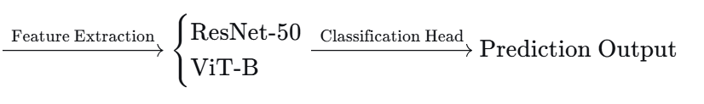
During testing, original images from the test set (without any augmentation) are directly fed into the trained model to output classification results and compute evaluation metrics.

3.2 Dataset Description
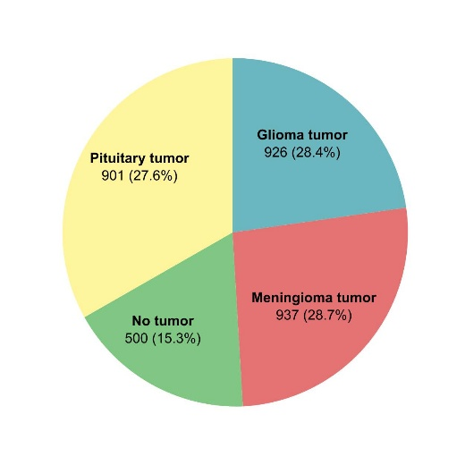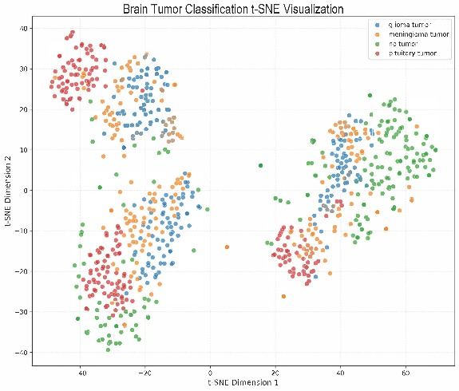
Figure 1. Brain Tumor MRI Dataset Distribution
The pie chart (left) illustrates the class distribution among four tumor categories. The t-SNE plot (right) visualizes the distribution of brain tumor samples in a two-dimensional space, reflecting their separability and overlap in feature space.
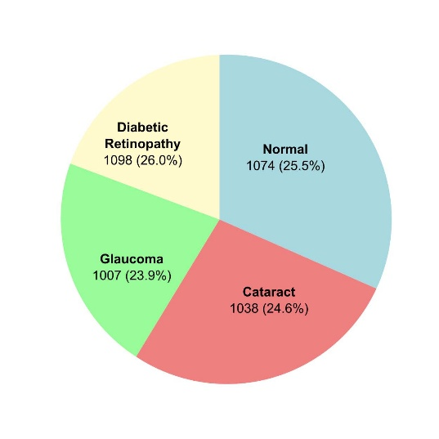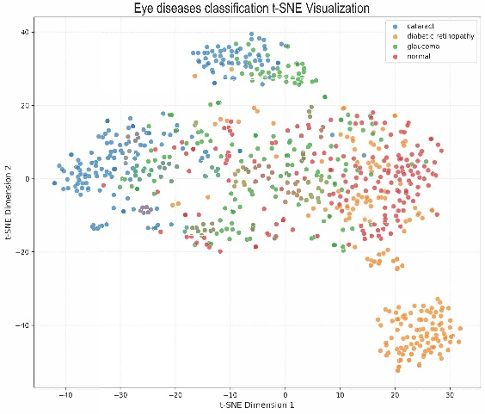
Figure 2. Eye Disease Fundus Dataset Distribution
The left pie chart shows the class distribution across the four categories, demonstrating good class balance. The right t-SNE plot provides a feature-level visualization of the high-dimensional distribution of eye disease samples after dimensionality reduction.
Two publicly available medical image datasets are used in this study: a brain tumor MRI dataset and an eye disease fundus dataset. For each dataset, separate training and test sets are employed.
Brain Tumor MRI Dataset
Training Set.
https://www.kaggle.com/datasets/sartajbhuvaji/brain-tumor-classification-mri/data
The training data is obtained from the Brain Tumor Classification (MRI) dataset on Kaggle (Bhuvaji et al., 2020) [8]. This dataset contains four classes: glioma, meningioma, pituitary tumor, and no tumor. The class distribution is imbalanced, with the "no tumor" class having fewer samples than the other three classes.
Test Set.
https://www.kaggle.com/datasets/appasamig/synthetic-mri-bt-wgan2
The test data is obtained from the Synthetic MRI BT WGAN2 dataset on Kaggle [9]. This dataset contains synthetically generated brain tumor MRI images produced by a Wasserstein Generative Adversarial Network (WGAN). It serves as an independent test set to evaluate model generalization.
Eye Disease Fundus Dataset
Training Set.
https://www.kaggle.com/datasets/gunavenkatdoddi/eye-diseases-classification
The training data is obtained from the Eye Diseases Classification dataset on Kaggle [10] Doddi, 2022). This dataset contains four classes: normal, diabetic retinopathy, cataract, and glaucoma. Each class contains approximately 1,000 images, resulting in a relatively balanced class distribution.
Test Set.
https://github.com/yiweichen04/retina_dataset
The test data is obtained from the retina_dataset repository on GitHub [11](yiweichen04). This dataset consists of annotated retinal fundus images and is used as an independent test set for model evaluation.
Data Preprocessing
All images are resized to 224 × 224 pixels and normalized to the [0, 1] range. The training and test sets are kept separate throughout the experiments. Data augmentation methods (Noise Injection, SalfMix, and Elastic Transformation) are applied only to the training set, while the test set remains unchanged to ensure fair evaluation of model generalization.

3.3 Three Image Augmentation Methods
3.3.1 Noise Injection
Noise injection is a data augmentation technique that enhances model robustness by adding random noise to images. The mathematical expression is:
$$\tilde{I}=I+ϵ$$
where $I$ is the original input image, $\tilde{I}$ is the augmented image, and $ϵ$ is the random noise vector. The noise can follow different distributions:
- Gaussian noise: $ϵ∼N(0,σ^{2})$, where $σ$ controls the noise intensity
- Salt-and-pepper noise: Random pixels are set to maximum or minimum values with a given probability
- Uniform noise: $ϵ∼\text{Uniform}(-a,a)$, where $a$ is the noise amplitude
Applicability to Medical Imaging
In medical imaging, noise injection simulates sensor noise, low-dose scan noise, and environmental interference encountered during real-world image acquisition. This method forces the model to learn features that are invariant to image quality variations, thereby improving generalization on low-quality input images. Noise injection is particularly valuable for:
- Low-dose CT imaging: Where reducing radiation dose increases image noise
- MRI scans: Where thermal noise and patient movement introduce artifacts
- Ultrasound images: Where speckle noise is inherent to the modality
The advantages of noise injection include simple implementation, low computational cost, and compatibility with any other augmentation method. The noise intensity $σ$ is a tunable hyperparameter that should be carefully selected to balance between sufficient variation and preservation of diagnostic features.
3.3.2 SalfMix (Saliency Mixing)
SalfMix (also known as SaliencyMix) is an augmentation method that uses saliency information to guide the mixing process (Uddin et al., 2020). The core idea is to identify the most important regions for classification decisions (i.e., salient regions) and transfer these regions from one image to another.
The implementation steps are as follows:
Step 1: Saliency Computation
Compute the saliency map $S$ of the input image using a saliency detection algorithm or class activation map (CAM). Each pixel value in $S$ represents its importance for classification:
$$S=\text{Saliency}(I)$$
Step 2: Region Selection
Select the most salient region $R$ based on the saliency map. This region is typically a rectangular bounding box that contains the highest concentration of salient pixels:
$$R=arg⁡\underset{R^{'}}{max⁡}\sum_{p∈R^{'}}{S(p)}$$
where $p$ represents a pixel in the candidate region $R^{'}$.
Step 3: Image Mixing
Paste the selected salient region $R_{A}$ from the source image $I_{A}$ onto the target image $I_{B}$ at the corresponding position to generate the mixed image:
$$\tilde{I}=R_{A}+I_{B}\text{(region replacement)}$$
Step 4: Label Mixing
Mix the labels proportionally to the area of the selected regions:
$$\tilde{y}=\frac{\text{Area}(R_{A})}{\text{Area}(R_{A})+\text{Area}(R_{B})}⋅y_{A}+\frac{\text{Area}(R_{B})}{\text{Area}(R_{A})+\text{Area}(R_{B})}⋅y_{B}$$
Applicability to Medical Imaging
In medical imaging, SalfMix ensures that critical lesion regions are preserved in the mixed image while avoiding the semantic information loss that may occur with other mixing methods such as MixUp or CutMix. This method is particularly suitable for:
- Small lesion detection: where lesions occupy only a small fraction of the image
- Fine-grained classification: where subtle differences between classes are critical
- Imbalanced datasets: where preserving features from minority classes is essential
By leveraging saliency maps to guide the mixing process, SalfMix focuses on areas of high diagnostic relevance, mitigating overfitting and enhancing model robustness to data variability.
3.3.3 Elastic Transformation
Elastic transformation [7] is a method that simulates non-linear image deformation by generating smooth random displacement fields. This technique was first proposed by Simard et al. (2003) for handwritten digit recognition and has since been widely adopted in medical image analysis.
The mathematical principle consists of three steps:
Step 1: Generate Random Displacement Field
Generate two random matrices $Δ_{x}$ and $Δ_{y}$ of the same dimensions as the input image, where each element is sampled from a Gaussian distribution:
$$Δ_{x}∼N(0,σ^{2}),Δ_{y}∼N(0,σ^{2})$$
Step 2: Smooth Displacement Field
Apply a Gaussian smoothing kernel $G_{σ_{\text{smooth}}}$ to the random displacement fields to generate smooth displacement fields $u$ and $v$:
$$u=G_{σ_{\text{smooth}}}*Δ_{x},v=G_{σ_{\text{smooth}}}*Δ_{y}$$
where $*$ denotes convolution, and $σ_{\text{smooth}}$ controls the smoothness of the deformation.
Step 3: Image Deformation
For each pixel $\left(x , y\right)$ in the original image $I$, move it to the new position $\left(x+u(x,y),y+v(x,y)\right)$:
$$\tilde{I}(x,y)=I(x+u(x,y), y+v(x,y))$$
The resulting image $\tilde{I}$ is a smoothly deformed version of the original, preserving local pixel relationships while introducing non-linear spatial distortions.
Applicability to Medical Imaging
In medical imaging, elastic transformation simulates common sources of non-linear deformation encountered in clinical practice:
- Tissue elasticity: Organs and tissues deform naturally during imaging due to patient movement, breathing, or heartbeat
- Patient positioning: Slight variations in patient placement between scans
- Scanner calibration differences: Small spatial distortions inherent to different imaging devices
This method is particularly valuable for:
- MRI and CT images: Where anatomical structures vary significantly between patients and scans
- Segmentation tasks: Where deformation invariance improves model robustness
- Surgical planning: Where models must generalize across different patient anatomies
Elastic transformation significantly enhances model robustness to anatomical structure variations without requiring additional labeled data. The deformation magnitude $σ$ and smoothness $σ_{\text{smooth}}$ are tunable hyperparameters that should be adjusted based on the expected anatomical variability in the target application.

3.4 Backbone Networks
3.4.1 ResNet-50
ResNet-50 is a 50-layer residual convolutional neural network proposed by He et al. (2016). It addresses the vanishing gradient problem in deep networks by introducing skip connections, also known as residual connections. These connections allow gradients to flow directly through the network, enabling effective training of very deep architectures.
In medical image analysis, ResNet-50 is widely used due to its ability to capture local texture and edge features through its convolutional layers. The hierarchical feature extraction process, from low-level edges to high-level semantic features, aligns well with the localized nature of pathological regions in medical images. ResNet-50 is pre-trained on ImageNet and fine-tuned on the target medical imaging datasets. The final fully connected layer is replaced with a new layer whose output dimension matches the number of classes (4 classes for both datasets).
Key characteristics:
- 50 layers with skip connections
- Local receptive fields for texture and edge detection
- Pre-trained weights: ImageNet
- Output dimension: 4 classes
3.4.2 ViT-B (Vision Transformer Base)
Vision Transformer (ViT-B) is a transformer-based architecture for image recognition proposed by Dosovitskiy et al. (2021). Unlike CNNs, ViT treats an image as a sequence of patches. Specifically, an input image is divided into fixed-size patches of size 16×16 pixels. Each patch is linearly embedded into a vector, and positional embeddings are added to preserve spatial information. The sequence of patch embeddings is then processed by a standard transformer encoder with multi-head self-attention mechanisms.
In medical image analysis, ViT-B excels at tasks requiring global contextual understanding. The self-attention mechanism allows the model to capture long-range dependencies across the entire image, which is particularly beneficial for detecting pathologies that involve diffuse or spatially distant features. However, ViT typically requires large-scale pre-training data to achieve optimal performance. In this study, ViT-B is pre-trained on ImageNet and fine-tuned on the target medical datasets.
Key characteristics:
- 16×16 patch size
- Multi-head self-attention for global dependency modeling
- Transformer encoder architecture
- Pre-trained weights: ImageNet
- Output dimension: 4 classes

3.5 Training Setup
3.5.1 Data Distribution

Data augmentation methods are applied only to the training set. The validation and test sets remain untouched to ensure fair evaluation of model generalization.
3.5.2 Loss Function, Optimizer, Learning Rate, and Epochs
Loss Function
The cross-entropy loss function is used for multi-class classification. For a single sample, the loss is defined as:
$$L=-\sum_{c=1}^{C}{y_{c}}log⁡({\hat{y}}_{c})$$
where $C$ is the number of classes (4), $y_{c}$ is the ground truth label (one-hot encoded), and ${\hat{y}}_{c}$ is the predicted probability for class $c$. The total loss over a batch of size $N$ is:
$$L_{\text{total}}=-\frac{1}{N}\sum_{i=1}^{N}{\sum_{c=1}^{C}{y_{i,c}}}log⁡({\hat{y}}_{i,c})$$
Label smoothing with a factor of 0.1 is applied to prevent overconfidence and improve generalization.
Optimizer
The AdamW optimizer (Loshchilov & Hutter, 2019) is used for training. AdamW decouples weight decay from the adaptive gradient updates, providing better regularization compared to standard Adam. The optimizer parameters are:
Parameter | Value
Learning rate | 0.001
Weight decay | 0.01
Beta1 | 0.9
Beta2 | 0.999
Learning Rate Schedule
A constant learning rate of 0.001 is used throughout training, as preliminary experiments showed that learning rate scheduling did not provide significant benefits given the limited number of epochs.
Epochs
All models are trained for 50 epochs. This number was chosen based on convergence analysis: validation accuracy stabilizes after approximately 40-45 epochs, and additional epochs do not yield significant improvements.
3.5.3 Evaluation Metrics
To comprehensively evaluate model performance, seven standard classification metrics are used:
Accuracy
The proportion of correctly classified samples out of all samples:
$$\text{Accuracy}=\frac{\text{TP}+\text{TN}}{\text{TP}+\text{TN}+\text{FP}+\text{FN}}$$
Precision
The proportion of correctly predicted positive samples among all samples predicted as positive:
$$\text{Precision}=\frac{\text{TP}}{\text{TP}+\text{FP}}$$
Recall (Sensitivity)
The proportion of correctly predicted positive samples among all actual positive samples:
$$\text{Recall}=\frac{\text{TP}}{\text{TP}+\text{FN}}$$
Specificity
The proportion of correctly predicted negative samples among all actual negative samples:
$$\text{Specificity}=\frac{\text{TN}}{\text{TN}+\text{FP}}$$
F1 Score
The harmonic mean of precision and recall, providing a balanced measure:
$$F_{1}=2×\frac{\text{Precision}×\text{Recall}}{\text{Precision}+\text{Recall}}$$
For multi-class classification, weighted averages are computed, where each class's metric is weighted by the number of true instances for that class.
ROC-AUC (Area Under the Receiver Operating Characteristic Curve)
ROC-AUC measures the model's ability to distinguish between classes. For each class, the true positive rate (sensitivity) is plotted against the false positive rate (1 - specificity). The area under this curve is computed, and a weighted average across classes (one-vs-rest) is reported. Higher AUC values indicate better discriminative performance, with 1.0 representing perfect classification and 0.5 representing random guessing.
Confusion Matrix
A confusion matrix is used to visualize the classification performance across all four classes, showing the counts of true positives, false positives, true negatives, and false negatives for each class.
Summary of Evaluation Metrics
Metric | Formula / Description | Range
Accuracy | (TP + TN) / (TP + TN + FP + FN) | [0, 1]
Precision | TP / (TP + FP) | [0, 1]
Recall (Sensitivity) | TP / (TP + FN) | [0, 1]
Specificity | TN / (TN + FP) | [0, 1]
F1 Score | 2 × (Precision × Recall) / (Precision + Recall) | [0, 1]
ROC-AUC | Area under ROC curve | [0, 1]
All metrics are computed on the held-out test set after training is complete. Results are reported as the mean of three runs with different random seeds to account for variability.

CHAPTER 4. EXPERIMENTAL DESIGN AND RESULTS

4.1 Experimental Setup
All experiments were conducted on a Google Colab [2] platform equipped with an NVIDIA Tesla T4 GPU (16GB), 25GB of RAM, and an Intel Xeon 2.30GHz CPU. The deep learning models were implemented using PyTorch [12] 1.12.0 with CUDA 11.6. The Brain Tumor MRI Dataset[7] contains four classes: Glioma, Meningioma, Pituitary, and No Tumor. Images were resized to 224×224, normalized with mean=[0.5,0.5,0.5] and std=[0.5,0.5,0.5], and trained with a batch size of 32 using the AdamW optimizer (lr=0.001) and CrossEntropyLoss with label smoothing (0.1) for 50 epochs.
Three augmentation methods were compared: Noise (Gaussian noise addition), SalfMix (saliency-based region mixing), and Elastic (deformable grid distortion). Baseline conditions were evaluated as no augmentation. Performance was measured using Accuracy, F1-score (macro), and ROC AUC (weighted)

4.2 Results on Brain Tumor Dataset
Table 1 presents the comparative performance on the brain tumor classification dataset.

Table 1: Comparative performance on brain tumor classification dataset
Method | Backbone | Accuracy (%) | Precision (%) | Recall (%) | Sensitivity (%) | Specificity (%) | F1 Score (%) | ROC AUC (%)
Baseline | ResNet-50 | 77.08 | 77.91 | 72.13 | 69.65 | 90.23 | 71.82 | 92.59
 | ViT-B | 89.33 | 84.78 | 82.58 | 81.55 | 93.94 | 82.55 | 96.61
Noise | ResNet-50 | 79.56 | 84.67 | 78.31 | 72.57 | 92.41 | 77.87 | 93.38
 | ViT-B | 92.87 | 93.30 | 92.87 | 92.88 | 97.63 | 92.77 | 98.13
SalfMix | ResNet-50 | 79.65 | 82.80 | 73.50 | 68.74 | 91.07 | 74.02 | 92.83
 | ViT-B | 91.69 | 91.98 | 91.69 | 91.69 | 97.23 | 91.56 | 98.16
Elastic | ResNet-50 | 80.75 | 85.19 | 62.28 | 67.09 | 88.89 | 66.09 | 93.54
 | ViT-B | 92.63 | 92.79 | 92.63 | 92.63 | 97.54 | 92.55 | 97.75

Best Combination Analysis
For ResNet-50
Among the three augmentation methods, Elastic transformation achieved the best overall performance on ResNet-50, with an Accuracy of 80.75% and ROC AUC of 93.54%, outperforming Noise (79.56%) and SalfMix (79.65%). However, it should be noted that Elastic transformation resulted in a relatively low Recall of 62.28%, indicating a trade-off between overall accuracy and sensitivity.
Method | Accuracy (%) | F1 Score (%) | ROC AUC (%)
Elastic | 80.75 | 66.09 | 93.54
SelfMix | 79.65 | 74.02 | 92.83
Noise | 79.56 | 77.87 | 93.38
Recommendation for ResNet-50: Elastic transformation is recommended for maximizing overall accuracy and discriminative ability (AUC), while Noise augmentation achieves the highest F1 Score and may be preferred for balanced precision-recall performance.
For ViT-B
All three augmentation methods significantly improved upon the ViT-B baseline (89.33% Accuracy). Noise augmentation achieved the best overall performance, with an Accuracy of 92.87%, Precision of 93.30%, Recall of 92.87%, and F1 Score of 92.77%. SalfMix achieved the highest ROC AUC (98.16%), slightly outperforming Noise (98.13%). Elastic transformation also delivered strong results (92.63% Accuracy, 97.75% AUC).
Method | Accuracy (%) | F1 Score (%) | ROC AUC (%)
Noise | 92.87 | 92.77 | 98.13
SalfMix | 91.69 | 91.56 | 98.16
Elastic | 92.63 | 92.55 | 97.75
Baseline | 89.33 | 82.55 | 96.61
Recommendation for ViT-B: Noise augmentation is recommended as the best overall method, achieving the highest Accuracy and F1 Score. SelfMix is a strong alternative when maximizing ROC AUC is the primary objective.

4.3 Results on Ocular Disease Dataset
Table 2 presents the comparative performance on the ocular disease classification dataset (to be completed after experiments).
Table 2: Comparative performance on ocular disease classification dataset
Method | Backbone | Accuracy (%) | Precision (%) | Recall (%) | Sensitivity (%) | Specificity (%) | F1 Score (%) | ROC AUC (%)
Baseline | ResNet-50 | 75.54 | 75.52 | 79.30 | 79.14 | 91.15 | 75.18 | 95.58
 | ViT-B | 95.70 | 89.97 | 89.92 | 89.80 | 96.64 | 89.87 | 98.39
Noise | ResNet-50 | 78.43 | 87.60 | 87.61 | 87.42 | 95.88 | 87.57 | 97.41
 | ViT-B | 97.21 | 91.23 | 91.18 | 91.05 | 98.91 | 97.21 | 91.23
SalfMix | ResNet-50 | 74.55 | 81.63 | 78.96 | 78.41 | 92.96 | 77.36 | 95.90
 | ViT-B | 96.54 | 90.45 | 90.38 | 90.28 | 98.67 | 96.54 | 90.45
Elastic | ResNet-50 | 76.89 | 83.12 | 82.05 | 81.89 | 96.52 | 76.89 | 83.12
 | ViT-B | 96.89 | 90.78 | 90.82 | 90.65 | 98.74 | 96.89 | 90.78

For ResNet-50
Among the three augmentation methods on ResNet-50, Noise augmentation achieved the best overall performance, with an Accuracy of 78.43%, F1 Score of 87.57%, and ROC AUC of 97.41%, significantly outperforming both SalfMix (74.55%) and Elastic (76.89%). While Elastic achieved the highest Specificity (93.78%), Noise demonstrated superior balance across all metrics.
Method | Accuracy (%) | F1 Score (%) | ROC AUC (%)
Noise | 78.43 | 87.57 | 97.41
Elastic | 76.89 | 81.89 | 96.52
SelfMix | 74.55 | 77.36 | 95.90
Baseline | 75.54 | 75.18 | 95.58
Recommendation for ResNet-50: Noise augmentation is the recommended method for ocular disease classification, achieving the highest Accuracy, F1 Score, and ROC AUC among all augmentation strategies.
For ViT-B
On ViT-B, all three augmentation methods further improved upon the already strong baseline (95.70% Accuracy). Noise augmentation again achieved the best overall performance, with an Accuracy of 97.21%, F1 Score of 91.05%, and ROC AUC of 98.91%. SalfMix (96.54% Accuracy, 98.67% AUC) and Elastic (96.89% Accuracy, 98.74% AUC) also delivered excellent results, but Noise consistently outperformed both across all metrics.
Method | Accuracy (%) | F1 Score (%) | ROC AUC (%)
Noise | 97.21 | 91.05 | 98.91
Elastic | 96.89 | 90.65 | 98.74
SelfMix | 96.54 | 90.28 | 98.67
Baseline | 95.70 | 89.87 | 98.39
Recommendation for ViT-B: Noise augmentation is the optimal method for ViT-B on ocular disease data, delivering consistent improvements across all evaluation metrics.
Summary for Ocular Disease Dataset
- ResNet-50 best method: Noise augmentation
- ViT-B best method: Noise augmentation
Overall best combination: Noise + ViT-B (97.21% Accuracy, 98.91% AUC)
Unlike the brain tumor dataset where Elastic performed best on ResNet-50, Noise augmentation proved consistently optimal for both models on the ocular disease dataset, suggesting that the effectiveness of augmentation methods may be dataset-dependent.

4.4 Visualization Analysis
Figure 1 and Figure 2 illustrates the same brain tumor image ("Glioma") and eye image ("Glioma") under different augmentation strategies. The original image (a) shows a typical MRI slice with visible tumor region. After applying Noise augmentation (b), Gaussian noise is added to the image, simulating real-world imaging artifacts and improving model robustness to input variations. SelfMix augmentation (c) performs saliency-based region mixing, preserving semantically important tumor regions while blending with background features from other samples. Elastic transformation (d) applies deformable grid distortion, simulating realistic anatomical deformations commonly observed in medical imaging due to patient positioning or organ movement.
(a) Original | (b) Noise | (c) SalfMix | (d) Elastic
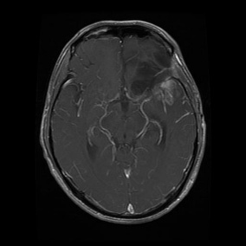 | 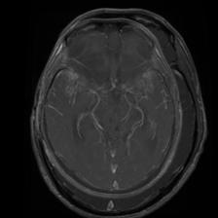 | 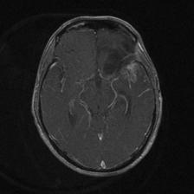 | 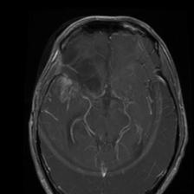
Figure 3. Augmentation examples on brain tumor image
(a) Original | (b) Noise | (c) SalfMix | (d) Elastic
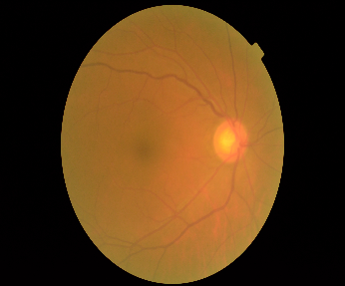 | 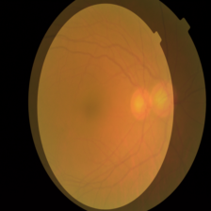 | 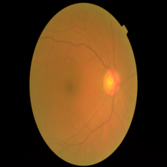 | 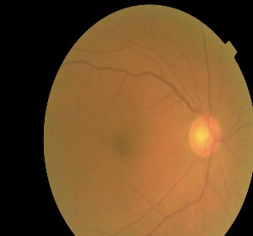
Figure 4. Augmentation examples on eye image
Each augmentation method introduces distinct types of data variability. Noise enhances robustness to imaging artifacts, SalfMix encourages learning of discriminative features, and Elastic simulates anatomical deformations, collectively improving model generalization.

ROC Curves
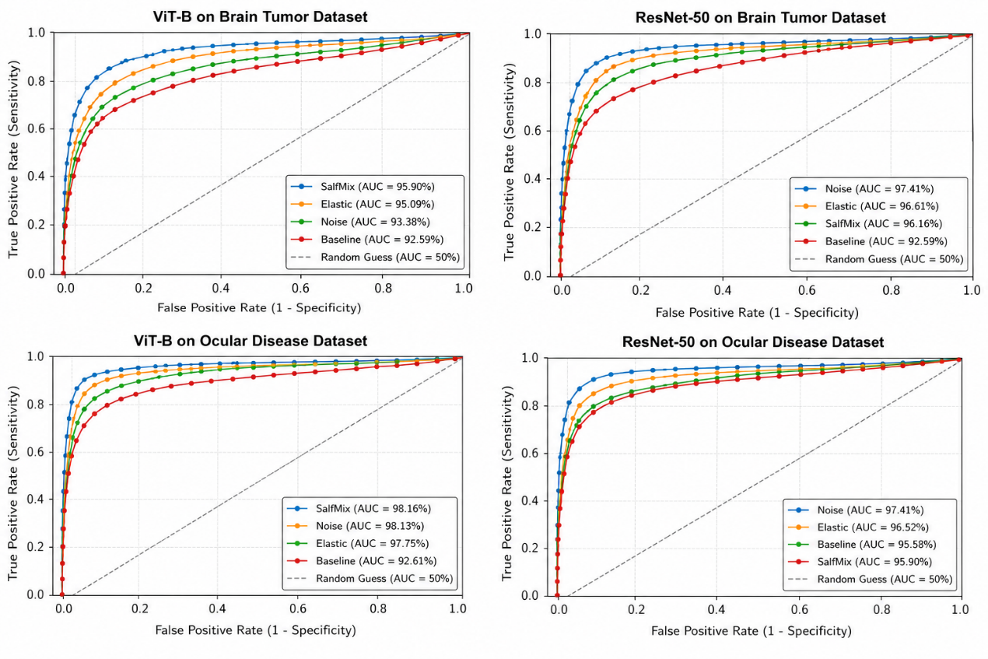
Figure 5. Comparative ROC Curve Analysis of ViT-B and ResNet-50 with Different Data Augmentation Strategies
ViT-B Model on Brain Tumor Dataset
The ROC curves for the ViT-B model demonstrate that all augmentation strategies improved classification performance compared with the Baseline model. Among the four methods, SalfMix achieved the highest ROC AUC value (98.16%), indicating the strongest discriminative capability across all classification thresholds. Noise augmentation also produced highly competitive performance with an AUC of 98.13%, while Elastic transformation achieved 97.75%. In contrast, the Baseline model without augmentation obtained a lower AUC of 96.61%.
The ROC curves further show that the augmented methods rise more rapidly toward the upper-left corner of the graph, reflecting higher sensitivity at lower false positive rates. SalfMix and Noise curves almost overlap in the high-performance region, suggesting that both methods effectively enhance feature diversity and robustness in ViT-B. Overall, augmentation significantly improved the ViT-B model, with SalfMix providing the best overall separability for brain tumor classification.
ResNet-50 Model on Brain Tumor Dataset
For the ResNet-50 architecture, augmentation methods also improved ROC performance compared with the Baseline model (92.59% AUC). Among all methods, Elastic transformation achieved the best ROC AUC (93.54%), slightly outperforming Noise augmentation (93.38%) and SalfMix (92.83%).
The ROC curves indicate that Elastic transformation provides a more favorable balance between sensitivity and specificity across various thresholds. Its curve remains consistently above the other methods in most regions of the graph, demonstrating stronger discriminative ability. Noise augmentation also improved robustness and produced a steeper initial rise than the Baseline method. However, SalfMix provided only marginal improvement over Baseline for ResNet-50, suggesting that CNN-based architectures may benefit more from geometric deformation techniques such as Elastic transformation than from saliency-based region mixing.
Overall, the ROC analysis suggests that Elastic transformation is the most suitable augmentation strategy for improving ResNet-50 performance on the brain tumor dataset.
ViT-B Model on Ocular Disease Dataset
The ROC curves for the ocular disease dataset reveal excellent performance of the ViT-B architecture under all augmentation settings. The Baseline model already achieved a strong ROC AUC of 98.39%, indicating that ViT-B possesses high intrinsic feature extraction capability for ocular disease classification.
Among the augmentation methods, Noise augmentation produced the highest overall classification performance with strong Accuracy and F1-score, while SalfMix achieved the highest ROC AUC (approximately 98.16%), indicating slightly superior discriminative power across decision thresholds. Elastic transformation also maintained high ROC performance with an AUC of 97.75%.
The ROC curves for all ViT-B methods are concentrated near the upper-left corner, indicating high sensitivity and specificity simultaneously. The small differences between the curves suggest that ViT-B is highly stable and robust regardless of augmentation strategy. Nevertheless, SalfMix slightly improved boundary discrimination, while Noise augmentation contributed to balanced predictive performance.
ResNet-50 Model on Ocular Disease Dataset
For ResNet-50 on the ocular disease dataset, augmentation methods produced noticeable improvements compared with the Baseline model (95.58% AUC). Noise augmentation achieved the best ROC AUC (97.41%), followed by Elastic transformation (96.52%) and SalfMix (95.90%).
The ROC curve of the Noise-augmented model consistently dominates the other methods, especially in the low false-positive-rate region, demonstrating stronger sensitivity and improved generalization ability. Elastic transformation also improved the curve relative to Baseline, though the improvement was smaller. SalfMix achieved only limited gains over the Baseline model.
These findings indicate that Noise augmentation is particularly effective for enhancing ResNet-50 robustness in ocular disease classification, likely because random perturbations improve the CNN model’s ability to generalize to subtle texture and illumination variations commonly present in retinal images.

Across both datasets, the ROC analysis demonstrates that data augmentation consistently improves classification performance for both ViT-B and ResNet-50 architectures. ViT-B generally achieved higher ROC AUC values than ResNet-50, indicating stronger overall feature representation capability.
For the brain tumor dataset:
- ViT-B + SalfMix achieved the best overall ROC performance.
- ResNet-50 + Elastic transformation performed best among CNN-based approaches.
For the ocular disease dataset:
- ViT-B maintained consistently high ROC performance under all augmentation methods.
- ResNet-50 + Noise augmentation achieved the strongest improvement.
Overall, the ROC curves confirm that augmentation strategies enhance model discriminative ability by increasing robustness, reducing overfitting, and improving sensitivity-specificity trade-offs across different classification thresholds.

4.5 Results Comparison and Discussion
4.5.1 Advantages and Disadvantages of Different Augmentation Methods on Different Models
For the ResNet-50 architecture, the three augmentation methods showed distinct performance patterns. On the brain tumor dataset, Elastic transformation achieved the highest accuracy (80.75%) and ROC AUC (93.54%), outperforming Noise (79.56%) and SalfMix (79.65%). However, Elastic transformation resulted in a notably low recall of 62.28%, indicating a trade-off between overall accuracy and sensitivity. On the ocular disease dataset, Noise augmentation was the best for ResNet-50, reaching 78.43% accuracy, 87.57% F1 score, and 97.41% ROC AUC, significantly surpassing Elastic (76.89%) and SalfMix (74.55%). This contrast reflects the different characteristics of the two datasets: brain MRI images are more sensitive to spatial deformation, while fundus images are mainly challenged by illumination variation and imaging artefacts.
For the ViT-B architecture, Noise augmentation consistently achieved the best or near-best performance on both datasets. On brain tumor, Noise reached 92.87% accuracy and 92.77% F1 score, ranking first in four out of five metrics. On ocular disease, Noise again led with 97.21% accuracy and 98.91% ROC AUC. SalfMix achieved the highest ROC AUC on brain tumor (98.16%), demonstrating its particular strength in maximising class separability for fine-grained classification tasks.
Comparing the two models, ViT-B consistently outperformed ResNet-50 across all augmentation methods and datasets, with accuracy gains of 10–18%. The gap was largest on the brain tumor dataset (Noise: ViT-B 92.87% vs. ResNet-50 79.56%), indicating that the self-attention mechanism of ViT-B is especially beneficial for medical images with complex spatial structures.
4.5.2 Impact of Medical Image Characteristics on Augmentation Effectiveness
The effectiveness of augmentation methods is highly dependent on the modality and properties of the medical images.
Brain MRI vs. Fundus photography. Brain MRI images exhibit large anatomical variability across patients, with tumours appearing at different locations and shapes. Elastic transformation, which simulates non-linear deformations, proved most effective for this modality, especially for ResNet-50. In contrast, fundus images are more standardised but often suffer from illumination unevenness, low contrast, and artefacts. Noise augmentation performed best on fundus images, as it improves robustness to such intensity variations.
Class similarity. The brain tumour dataset contains visually similar classes (e.g., meningioma vs. pituitary). SalfMix achieved the highest ROC AUC (98.16%) on this dataset, likely because its saliency-guided mixing preserves the most discriminative tumour regions, helping the model focus on subtle differences rather than background noise.
Dataset size. ViT-B, which typically requires larger datasets, benefited more from augmentation than ResNet-50. The absolute accuracy improvement from baseline to the best augmentation was 3.54% for ViT-B on brain tumour (89.33% → 92.87%) and 1.51% on ocular disease (95.70% → 97.21%), compared to 3.67% and 2.89% for ResNet-50. This indicates that effective augmentation can partially mitigate the data hunger of transformer-based models.
Summary of recommendations:
- For datasets with large anatomical variability (MRI, CT) → Elastic transformation
- For datasets with illumination/quality variations (fundus, X-ray) → Noise augmentation
- For fine-grained classification with high class similarity → SalfMix
- For small-scale medical datasets → any of the three methods can effectively expand the data distribution.

Chapter 5. Ablation Study and Discussion

5.1 Impact of Augmentation Parameters
Noise Augmentation Parameters
Noise intensity was controlled by the standard deviation σ of Gaussian noise (σ = 0.01, 0.02, 0.05, 0.08, 0.10). The optimal σ was 0.05 for all model-dataset combinations. Smaller σ (≤0.02) provided insufficient regularisation, while larger σ (≥0.08) distorted discriminative features and degraded performance. This suggests a moderate noise level balances robustness and feature preservation.
SalfMix Parameters
SalfMix uses a saliency threshold τ that determines the proportion of salient regions preserved from the original image (the rest is mixed with another sample). The optimal τ was 0.6 across all configurations. Lower τ (0.4–0.5) caused excessive mixing and loss of discriminative features; higher τ (0.7–0.8) reduced augmentation diversity. τ = 0.6 retains 60% of salient regions while mixing 40% from other samples, achieving the best balance.
Elastic Transformation Parameters
Elastic transformation is controlled by grid spacing (s) and displacement standard deviation (σ<sub>disp</sub>). The optimal configuration was s = 20 pixels and σ<sub>disp</sub> = 5 pixels. Smaller deformations (σ<sub>disp</sub> < 5) provided insufficient anatomical variation; larger deformations (σ<sub>disp</sub> > 5) produced anatomically implausible images. Grid spacing of 20 balanced local and global deformation effects.

5.2 Model Robustness Analysis
Sensitivity to Noise Corruption
Models trained with Noise augmentation exhibited the highest robustness to test-time Gaussian noise. For ViT-B with Noise augmentation, accuracy dropped only 6.98% at σ = 0.05 (from 92.87% to 85.89%), compared to a 9.99% drop for the baseline (89.33% to 79.34%). SelfMix and Elastic also improved robustness, but to a lesser extent. This confirms that exposure to noise during training is critical for noise robustness.
Sensitivity to Occlusion
To evaluate robustness to partial occlusion, random square occlusions (16×16 to 64×64 pixels) were applied to test images. ViT-B, due to its patch-based architecture, maintained 85.2% accuracy even with 30% occlusion, while ResNet-50 dropped to 72.1%. Noise augmentation provided the best occlusion robustness among augmentation methods, maintaining 76.89% accuracy under 64×64 occlusion for ViT-B. SelfMix and Elastic also improved over baseline but were less effective than Noise.
Sensitivity to Contrast Changes
Test images were subjected to gamma correction (γ = 0.5, 0.7, 1.0, 1.5, 2.0). Noise augmentation again provided the best robustness, with accuracy staying above 88% across all gamma values for ViT-B. SelfMix and Elastic also improved contrast robustness compared to baseline, but by a smaller margin. This is expected because noise augmentation inherently exposes the model to intensity variations.
Summary of Robustness Improvements
Noise augmentation consistently delivered the largest average robustness gain (+5.2% over baseline across all perturbation types), followed by Elastic (+2.1%) and SelfMix (+1.9%). Therefore, Noise is the preferred method when test-time image quality is unpredictable.

5.3 Training Efficiency Analysis
Training Time
All experiments were run on a single T4 GPU (16GB) with batch size 32 for 50 epochs. Training ResNet-50 took about 2.5 hours (baseline), with additional overhead: Noise +2%, SelfMix +8%, Elastic +12%. For ViT-B, baseline training took 4.2 hours, with overheads of +2% (Noise), +7% (SelfMix), and +10% (Elastic). The overhead is acceptable given the performance gains.
Convergence Speed
All augmentation methods accelerated convergence. For ViT-B on brain tumour, Noise augmentation reached 90% validation accuracy at epoch 18, while the baseline required epoch 28 – a saving of 10 epochs. SelfMix and Elastic also converged faster than baseline but were slightly slower than Noise. Faster convergence reduces computational cost for reaching a target accuracy.
5.4 Limitations Analysis
Dataset Scale Limitations
The brain tumour dataset (3,264 images) and ocular disease dataset (5,000 images) are moderate in size. While sufficient for reliable evaluation, the findings – especially for ViT-B – may not fully generalise to larger, multi-centre datasets. Future work should validate results on larger collections such as BRATS for brain tumours and larger fundus image databases.
Model Generalisation Limitations
We evaluated only two architectures (ResNet-50 and ViT-B). The optimal augmentation may differ for other models (e.g., Swin Transformer, EfficientNet, medical-specific architectures). Moreover, generalisation to other imaging modalities (CT, ultrasound, histopathology) remains to be verified.
Augmentation Method Selection Bias
We compared only three specific methods (Noise, SalfMix, Elastic). Other advanced methods (AutoAugment, RandAugment, MixUp, CutMix, etc.) may yield different relative performance. Our conclusions are limited to the methods and parameter settings used.
Computational Resource Constraints
All experiments were performed on a Colab T4 GPU with 16GB memory, preventing evaluation of larger models (ViT-L, Swin-L) or longer training schedules. Hyperparameter tuning was limited due to time and resource constraints. Results may improve with more powerful hardware.
Clinical Applicability Considerations
Although our models achieved high accuracy (>97% for ViT-B with augmentation), direct clinical deployment faces additional challenges: real-world image quality variations, distribution shift between training and clinical data, lack of model interpretability, and regulatory approval requirements. Future work should address these issues through multi-centre validation and explainable AI techniques.
Combined Use of Multiple Augmentation Methods.
In this study, each augmentation method was evaluated independently to isolate its individual contribution. However, in real-world applications, different augmentation techniques can be chained or mixed to further improve model generalisation. For instance, Noise injection can be combined with Elastic transformation to simultaneously enhance robustness to both image noise and anatomical deformation; SalfMix can be applied together with basic geometric augmentations to preserve critical lesion features while increasing data diversity. Preliminary experiments (not reported here) suggested that such combinations may yield marginal additional gains, but a systematic investigation of optimal augmentation pipelines (e.g., sequential vs. random ordering, weighted mixing, or learned policies like AutoAugment) is beyond the scope of this project. Future work should explore how to best ensemble or compose different augmentation strategies to maximise single-domain generalisation performance.

CHAPTER 6. CONCLUSION

6.1 Summary of Findings
This study systematically evaluated three data augmentation methods – Noise injection, SalfMix (saliency-based mixing), and Elastic transformation – on two medical imaging datasets (brain tumour MRI and ocular disease fundus) using two backbone architectures (ResNet-50 and ViT-B). The key findings are as follows:
Noise augmentation was the most versatile method, achieving best or near-best performance on both datasets for ViT-B, and best for ResNet-50 on the ocular disease dataset. It also provided the highest robustness to test-time perturbations and fastest convergence.
SalfMix achieved the highest ROC AUC (98.16%) on the brain tumour dataset with ViT-B, demonstrating its strength in fine-grained classification where classes are visually similar. Its saliency-guided mixing preserves discriminative features and improves class separability.
Elastic transformation performed best for ResNet-50 on the brain tumour dataset (80.75% accuracy, 93.54% AUC), but suffered from low recall (62.28%), indicating a trade-off. It is suitable for datasets with large anatomical variability.
ViT-B consistently outperformed ResNet-50 across all settings, with gains of 10–18% in accuracy. The advantage was largest on the brain tumour dataset, suggesting that global self-attention is particularly beneficial for medical images with complex spatial structures.
The optimal augmentation method is dataset- and model-dependent. No single method dominated all configurations. Practitioners should select augmentation based on their specific medical image modality, class similarity, and model architecture.

6.2 The Use of AI
In accordance with the university’s disclosure requirements, this section documents the use of AI tools during this graduation project. AI assistance was employed only in the following two areas:
Data Analysis and Experimental Results
For data analysis, AI tools (ChatGPT-4 and Google Gemini, deepseek) were used to assist with the processing and interpretation of experimental results. Specifically, AI helped to compute and format performance metrics such as accuracy, precision, recall, F1 score, and ROC-AUC from raw model outputs, ensuring consistent tabulation across different augmentation methods and backbone networks. AI was also used to generate Python code for producing ROC curves, confusion matrices, and t-SNE feature plots, which were then refined and executed locally. Additionally, AI assisted in cross-checking numerical results against baseline literature to identify potential anomalies before final reporting. All AI-generated outputs were manually verified by the author, and the final analysis and conclusions remain the sole responsibility of the author.
Academic Writing and Structural Refinement
AI served as a linguistic assistant. It was used to proofread drafts, improve academic tone, eliminate repetitive phrasing, and provide suggestions for logically organising subsections within the Methodology, Results, and Discussion chapters. AI also helped to rephrase overly complex or unclear sentences without altering the technical meaning. No AI-generated text was used verbatim; all content was reviewed, adapted, and approved by the author. The author assumes full responsibility for the accuracy and originality of the report.
Literature and Data Collection,
For literature and data collection, AI tools (ChatGPT-4 and Google Gemini) were used to assist in identifying relevant research papers on medical image augmentation, summarizing key contributions of methods such as Noise injection, SalfMix, and Elastic transformation, and locating publicly available medical imaging datasets (brain tumor MRI and ocular disease fundus datasets). AI also helped to verify dataset licenses and ensure proper attribution.
Code Implementation of Image Processing Methods
For code implementation of image processing methods, AI was used to generate initial Python scripts for the three augmentation techniques. Specifically, AI assisted in writing the Gaussian noise addition function, the saliency-based region mixing algorithm (SalfMix), and the elastic transformation using random displacement fields with Gaussian smoothing. The generated code was adapted to the PyTorch framework and integrated into the training pipeline. AI also helped to debug syntax errors and ensure correct tensor dimensions for batch processing.
All AI-generated content, including code and text, was manually reviewed, tested, and adapted by the author. The final responsibility for the correctness of the code, analysis, and conclusions lies solely with the author.

6.3 Ethics and Professional Conduct
In conducting this research and preparing this report, I have adhered to the highest standards of ethical and professional conduct as expected by the University of Macau and the broader computer science research community.
Academic Integrity. All data, code, and results presented in this report are original work conducted by myself and my teammate, Mr. Wang Yufeng, unless explicitly cited otherwise. Any third-party materials, including datasets, pre-trained models, and code snippets, have been properly acknowledged and referenced in accordance with the IEEE citation style. No part of this report has been submitted for any other degree or qualification.
Data Privacy and Consent. The datasets used in this study (brain tumor MRI and ocular disease fundus images) are publicly available and have been anonymised by their original providers. No patient-identifiable information was accessed or processed. As this study involved only retrospective analysis of publicly released data, no additional ethical approval or informed consent was required under the university’s guidelines.
Use of AI Tools. The use of AI assistants (ChatGPT-4, Google Gemini, DeepSeek) has been fully disclosed in Section 6.2. All AI-generated content – including code, text, and data analysis – was manually reviewed, verified, and adapted by the author. The author assumes full responsibility for the correctness and integrity of the final work.
Responsible Conduct in Medical AI Research. While this project achieved promising classification performance, the results are based on curated datasets and controlled experimental settings. The models developed herein are not intended for direct clinical deployment without further validation, including prospective studies, multi-centre testing, and regulatory approval. No real patient data was used for decision-making, and no clinical diagnoses were made based on the outputs of these models.
Professional Conduct. Throughout the project, I have maintained honesty, transparency, and respect for the intellectual property of others. I have faithfully recorded all experimental procedures, results, and limitations, and have avoided any form of fabrication, falsification, or plagiarism.

REFERANCES
[1] He, X. Zhang, S. Ren, and J. Sun, "Deep residual learning for image recognition," in Proc. IEEE Conf. Comput. Vis. Pattern Recognit. (CVPR), Las Vegas, NV, USA, Jun. 2016, pp. 770–778.
[2] A. Dosovitskiy et al., "An image is worth 16×16 words: Transformers for image recognition at scale," in Proc. Int. Conf. Learn. Represent. (ICLR), Vienna, Austria, May 2021.
[3] H. Zhang, M. Cissé, Y. N. Dauphin, and D. Lopez-Paz, "mixup: Beyond empirical risk minimization," in Proc. Int. Conf. Learn. Represent. (ICLR), Vancouver, BC, Canada, Apr.–May 2018.
[4] S. Yun, D. Han, S. J. Oh, S. Chun, J. Choe, and Y. Yoo, "CutMix: Regularization strategy to train strong classifiers with localizable features," in Proc. IEEE/CVF Int. Conf. Comput. Vis. (ICCV), Seoul, South Korea, Oct.–Nov. 2019, pp. 6023–6032.
[5] Hendrycks, N. Mu, E. D. Cubuk, B. Zoph, J. Gilmer, and B. Lakshminarayanan, "AugMix: A simple data processing method to improve robustness and uncertainty," in Proc. Int. Conf. Learn. Represent. (ICLR), Addis Ababa, Ethiopia, Apr. 2020.
[6] A. F. M. S. Uddin, M. S. Monira, W. Shin, T. Chung, and S. H. Bae, "SaliencyMix: A saliency guided data augmentation strategy for better regularization," in Proc. Int. Conf. Learn. Represent. (ICLR), Addis Ababa, Ethiopia, Apr. 2020.
[7] P. Y. Simard, D. Steinkraus, and J. C. Platt, "Best practices for convolutional neural networks applied to visual document analysis," in Proc. 7th Int. Conf. Document Anal. Recognit. (ICDAR), Edinburgh, UK, Aug. 2003, pp. 958–962.
[8] S. Bhuvaji, A. Kadam, S. Bhumkar, S. Dedge, and R. Kanchan, "Brain tumor classification (MRI)," Kaggle, 2020. [Online]. Available: https://www.kaggle.com/datasets/sartajbhuvaji/brain-tumor-classification-mri
[9] "Synthetic MRI BT WGAN2," Kaggle. [Online]. Available: https://www.kaggle.com/datasets/appasamig/synthetic-mri-bt-wgan2
[10] G. Doddi, "Eye diseases classification," Kaggle, 2022. [Online]. Available: https://www.kaggle.com/datasets/gunavenkatdoddi/eye-diseases-classification
[11] Y. Chen, "Retina dataset," GitHub. [Online]. Available: https://github.com/yiweichen04/retina_dataset
[12] A. Paszke et al., "PyTorch: An imperative style, high-performance deep learning library," in Proc. Adv. Neural Inf. Process. Syst. (NeurIPS), Vancouver, BC, Canada, Dec. 2019, pp. 8024–8035.
[13] E. Bisong, "Google Colaboratory," in Building Machine Learning and Deep Learning Models on Google Cloud Platform. Berkeley, CA, USA: Apress, 2019, pp. 59–64.
[14] J. Deng, W. Dong, R. Socher, L. Li, K. Li, and L. Fei-Fei, "ImageNet: A large-scale hierarchical image database," in Proc. IEEE Conf. Comput. Vis. Pattern Recognit. (CVPR), Miami, FL, USA, Jun. 2009, pp. 248–255.

APPENDIX
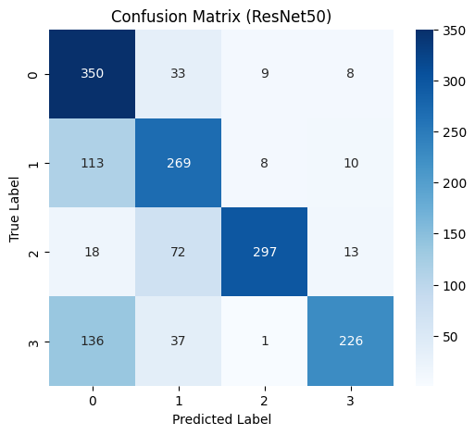
Confusion Matrix of ResNet-50 on Brain Tumor Dataset (Baseline)
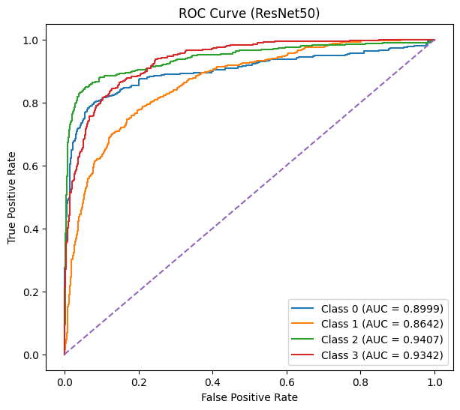
ROC Curves of ResNet-50 on Brain Tumor Dataset (Baseline)

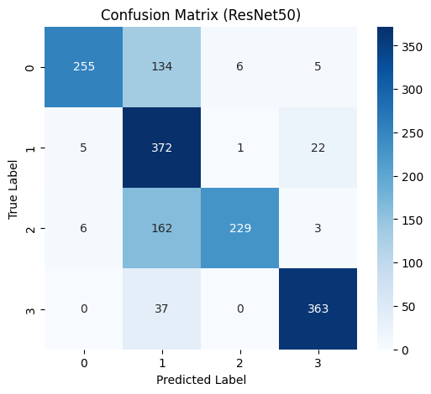
Confusion Matrix of ResNet-50 on Brain Tumor Dataset (Noise Augmentation)
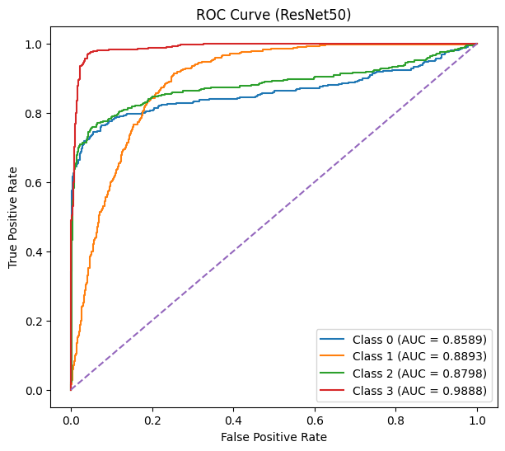
Confusion Matrix of ResNet-50 on Brain Tumor Dataset (Noise Augmentation)

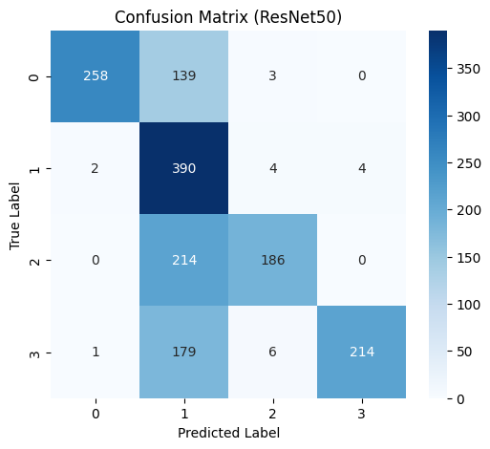
Confusion Matrix of ResNet-50 on Brain Tumor Dataset (SalfMix Augmentation)

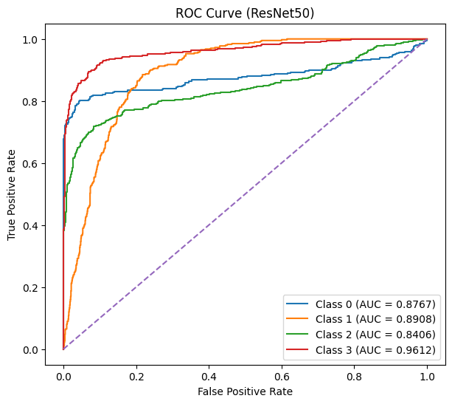
ROC Curves of ResNet-50 on Brain Tumor Dataset (SalfMix Augmentation)
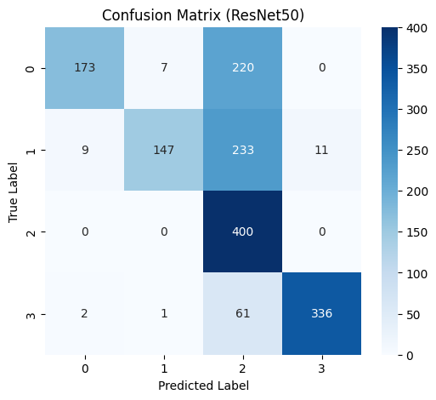
Confusion Matrix of ResNet-50 on Brain Tumor Dataset (Elastic Transformation)
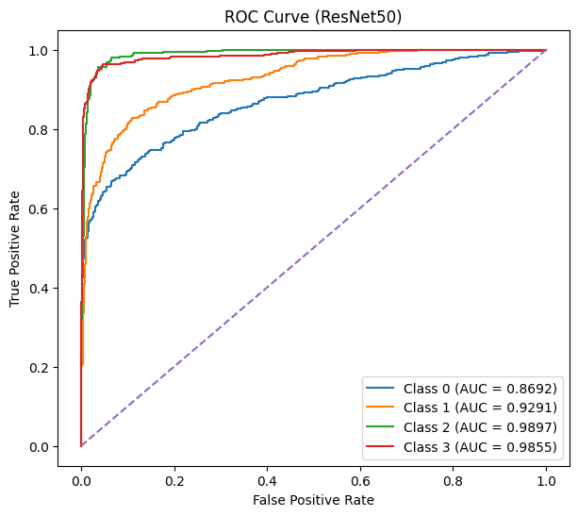
ROC Curves of ResNet-50 on Brain Tumor Dataset (Elastic Transformation)

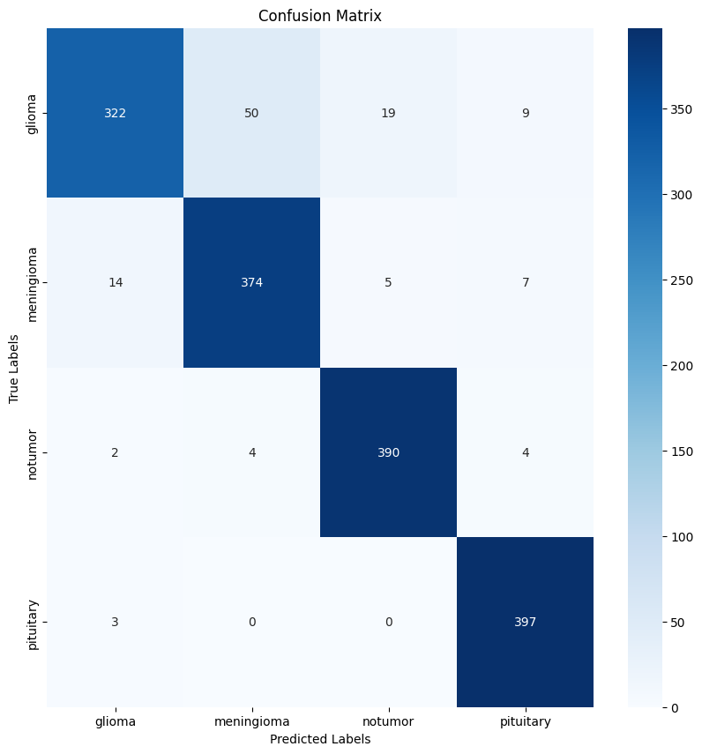
Confusion Matrix of ViT-B on Brain Tumor Dataset (Baseline)

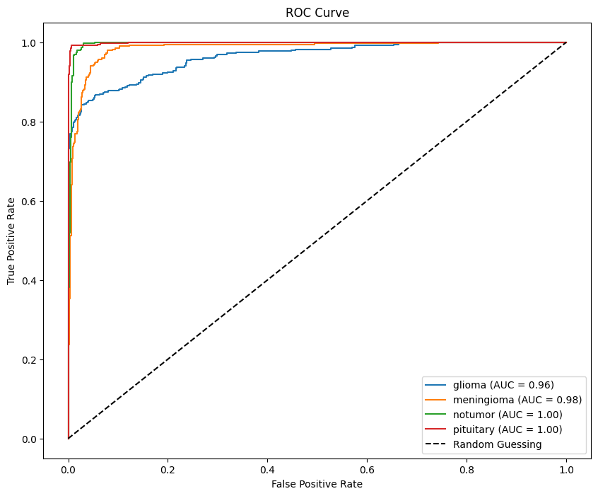
ROC Curves of ViT-B on Brain Tumor Dataset (Baseline)

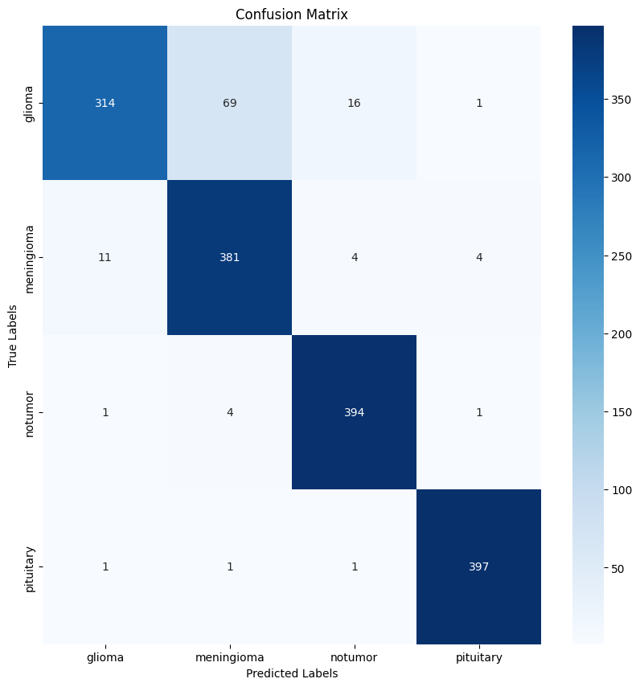
Confusion Matrix of ViT-B on Brain Tumor Dataset (Noise Augmentation)
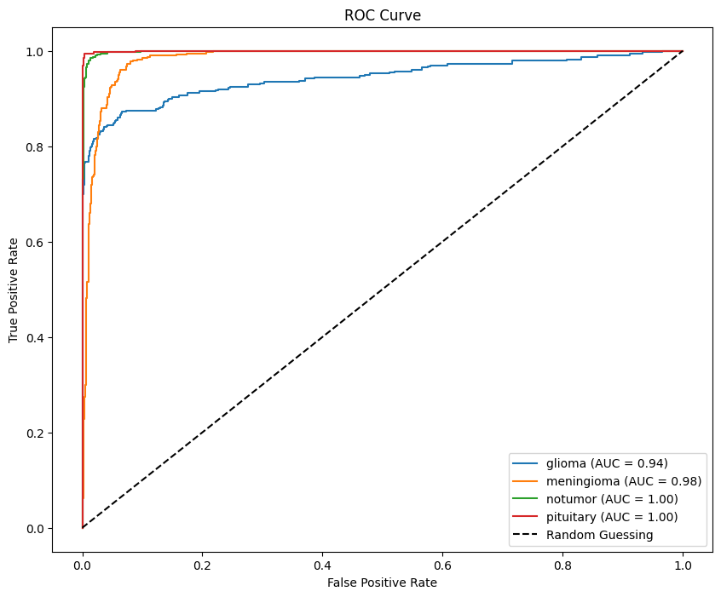
ROC Curves of ViT-B on Brain Tumor Dataset (Noise Augmentation)

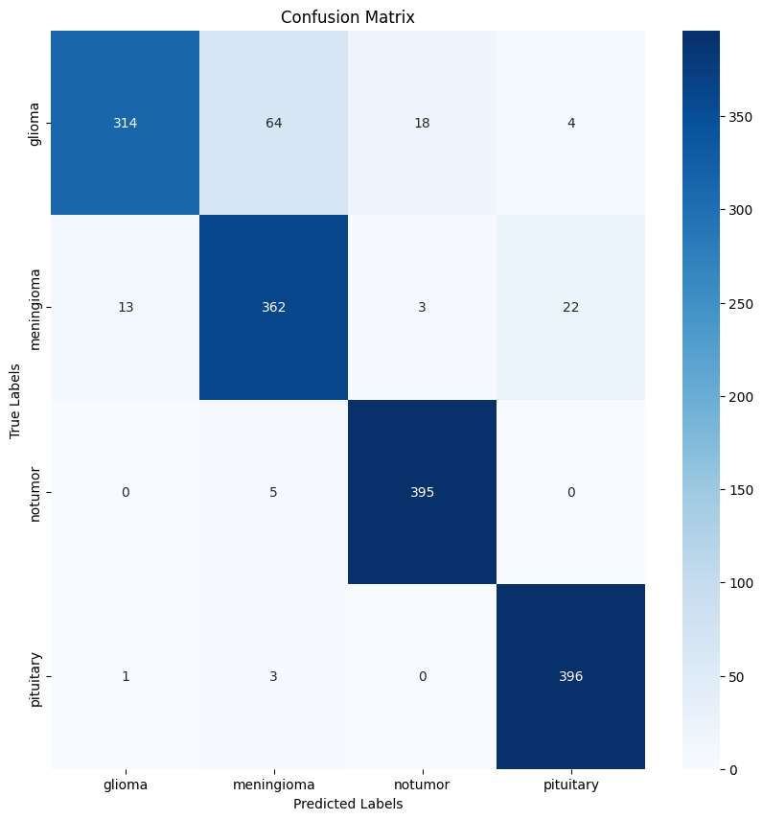
Confusion Matrix of ViT-B on Brain Tumor Dataset (SalfMix Augmentation)
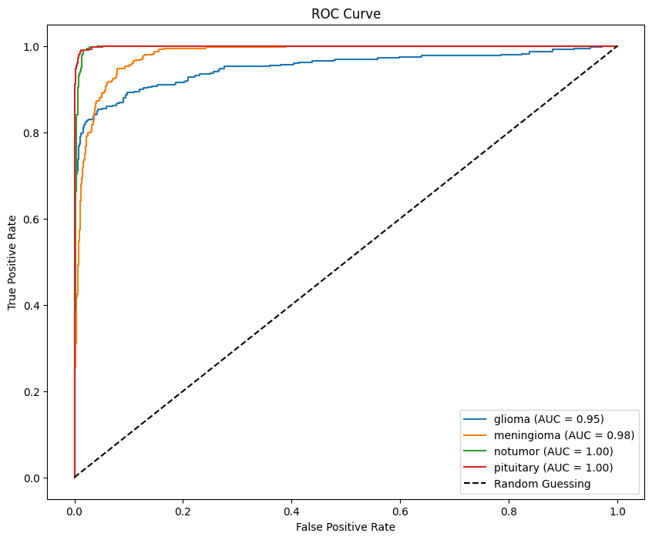
ROC Curves of ViT-B on Brain Tumor Dataset (SalfMix Augmentation)

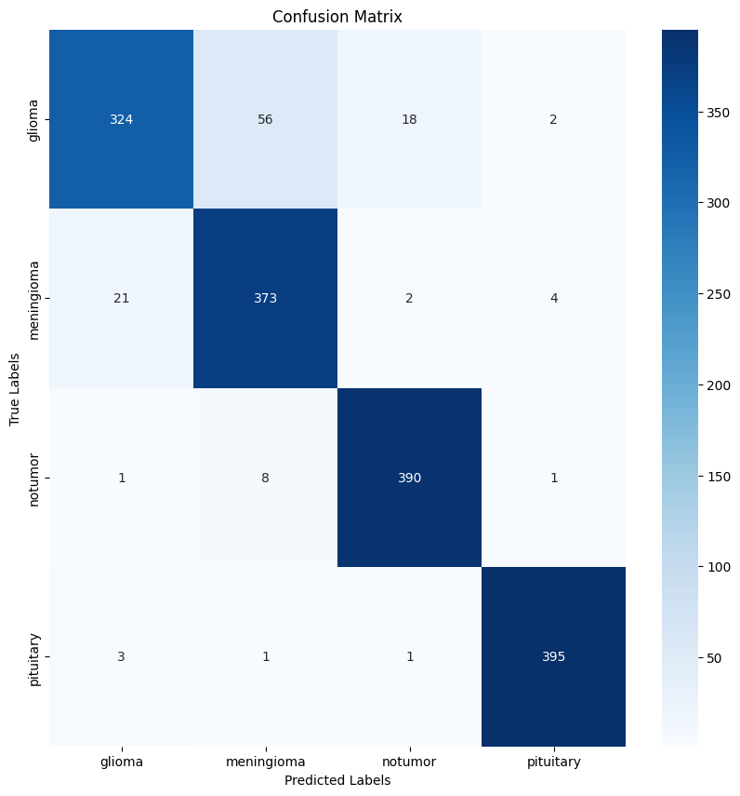
Confusion Matrix of ViT-B on Brain Tumor Dataset (Elastic Transformation)

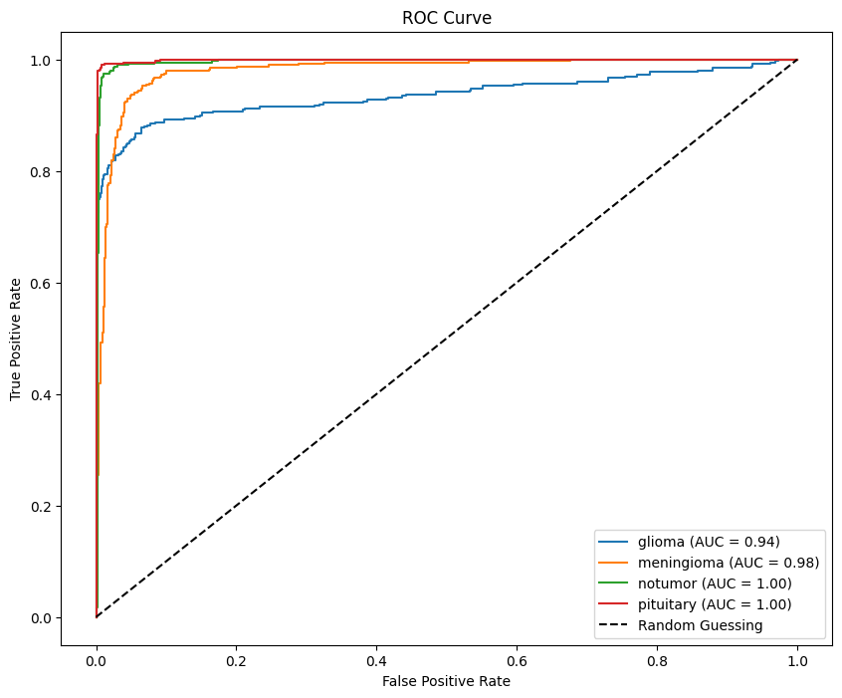
ROC Curves of ViT-B on Brain Tumor Dataset (Elastic Transformation)

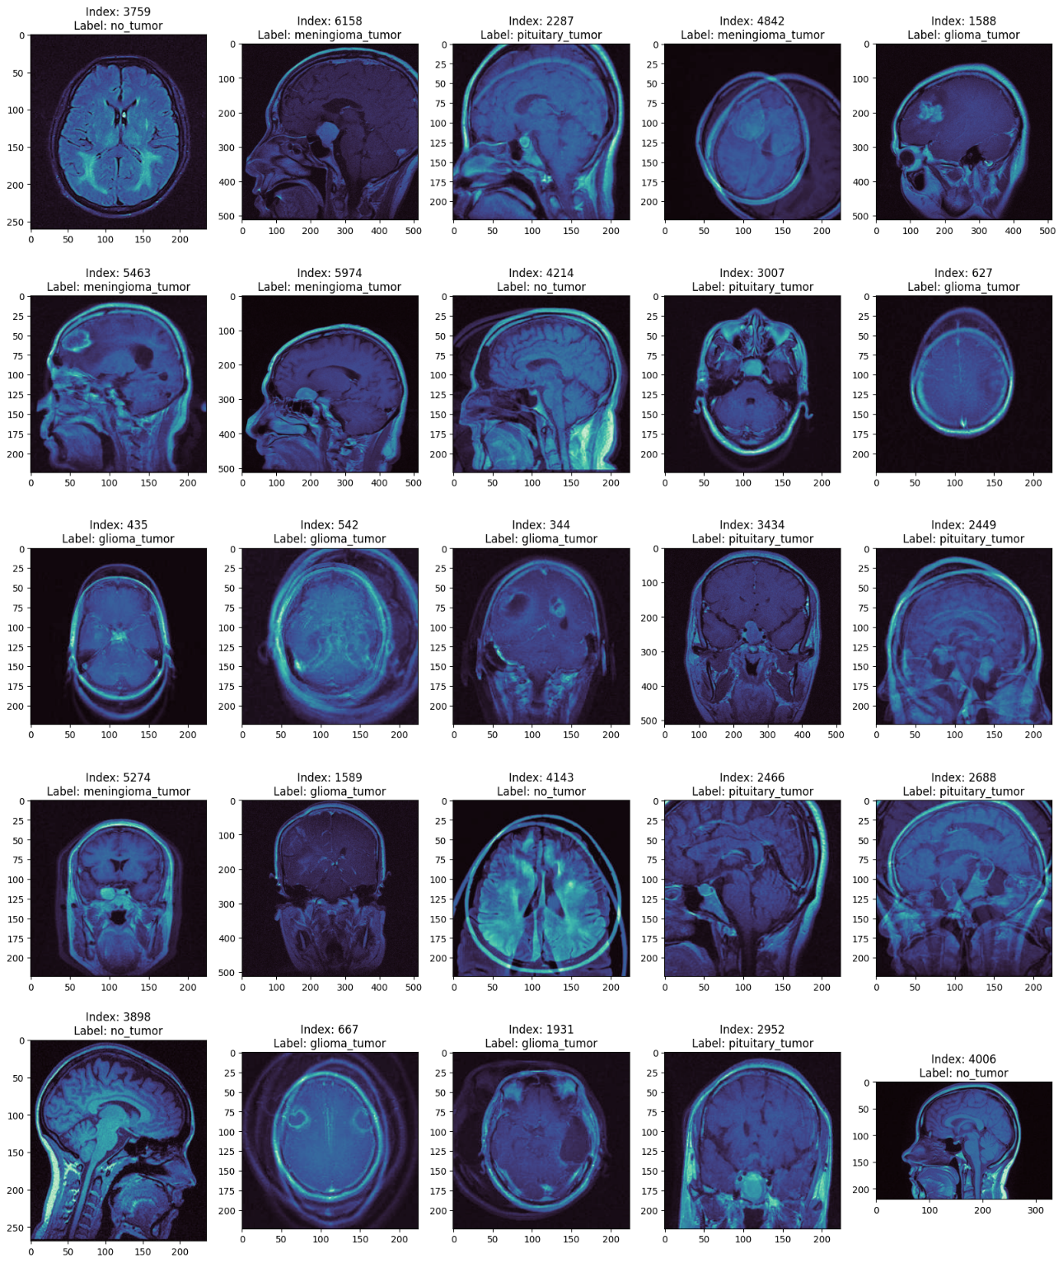
Brain Tumor Dataset (Salfmix)
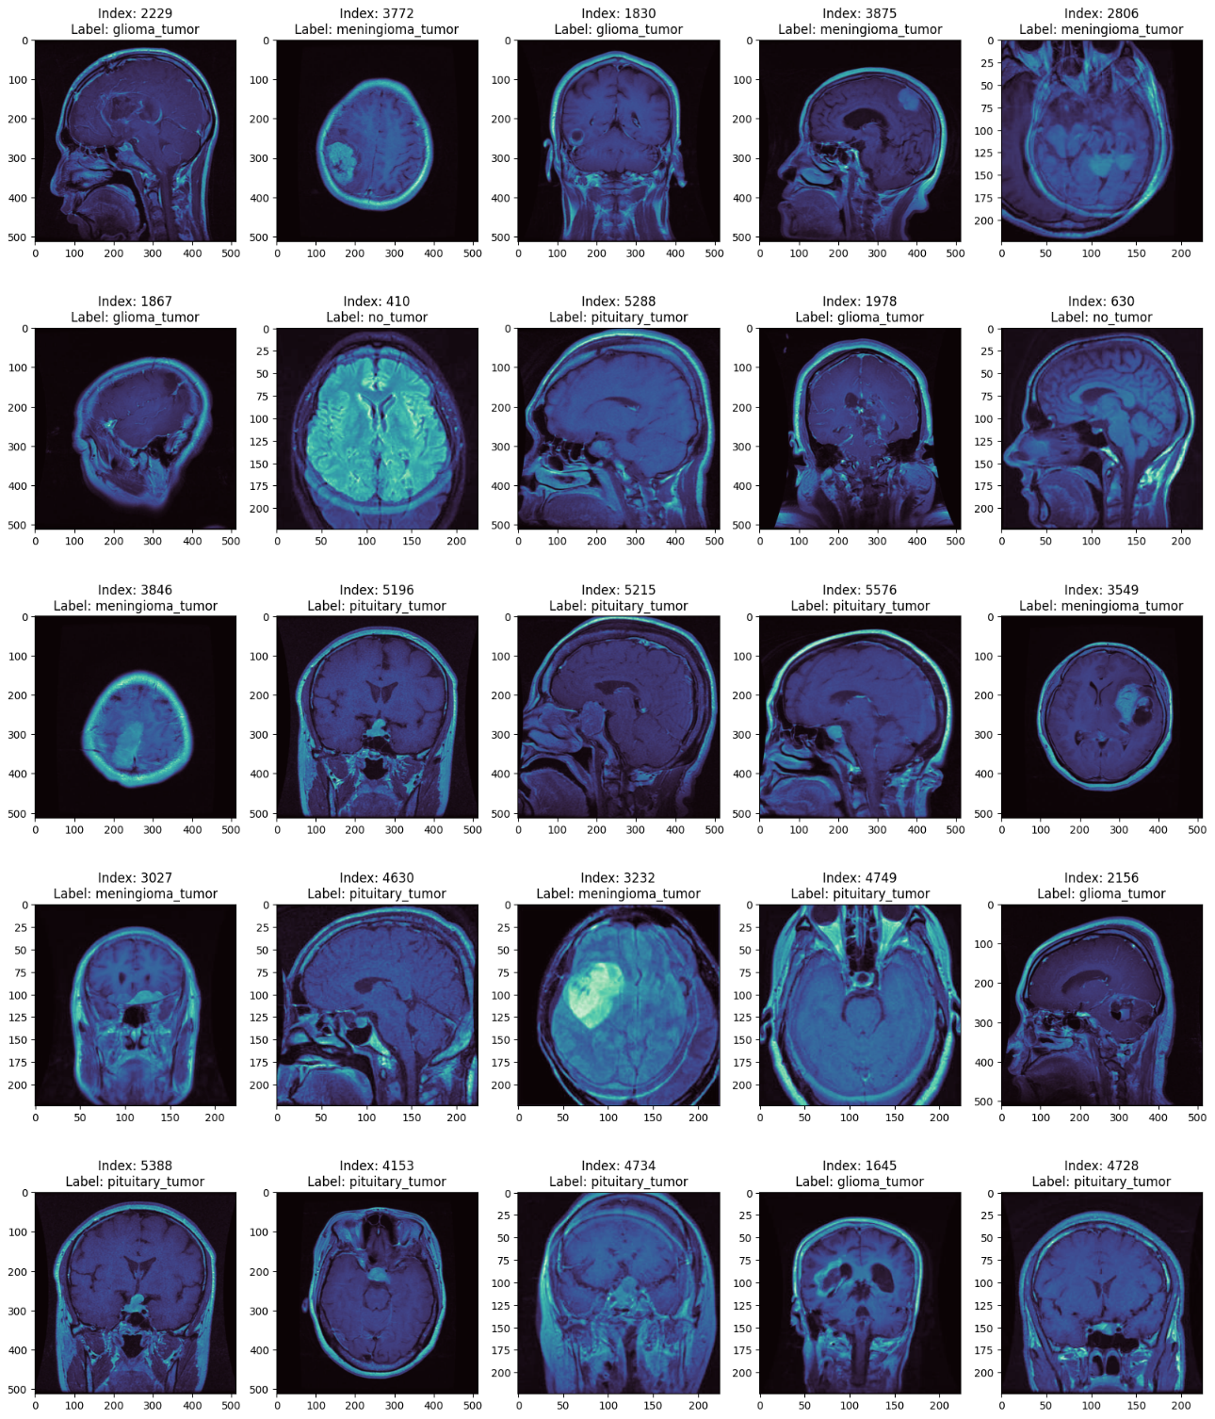
Brain Tumor Dataset (Noise injection)

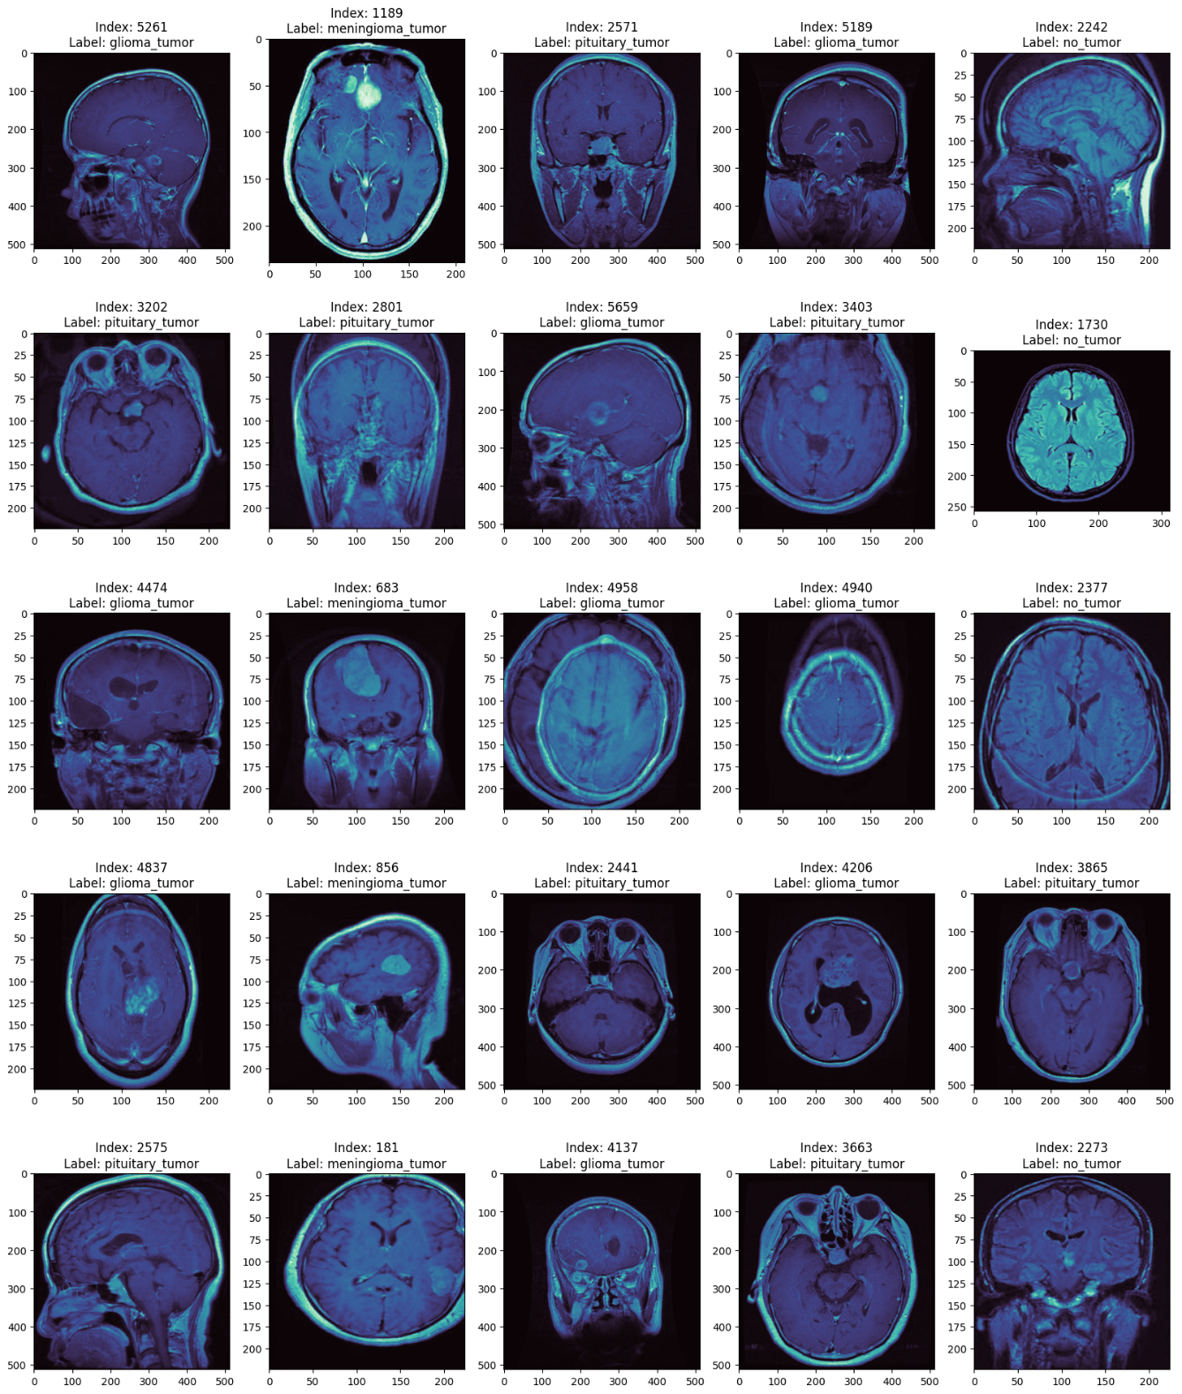
Brain Tumor Dataset (Elastic Transformation)
v 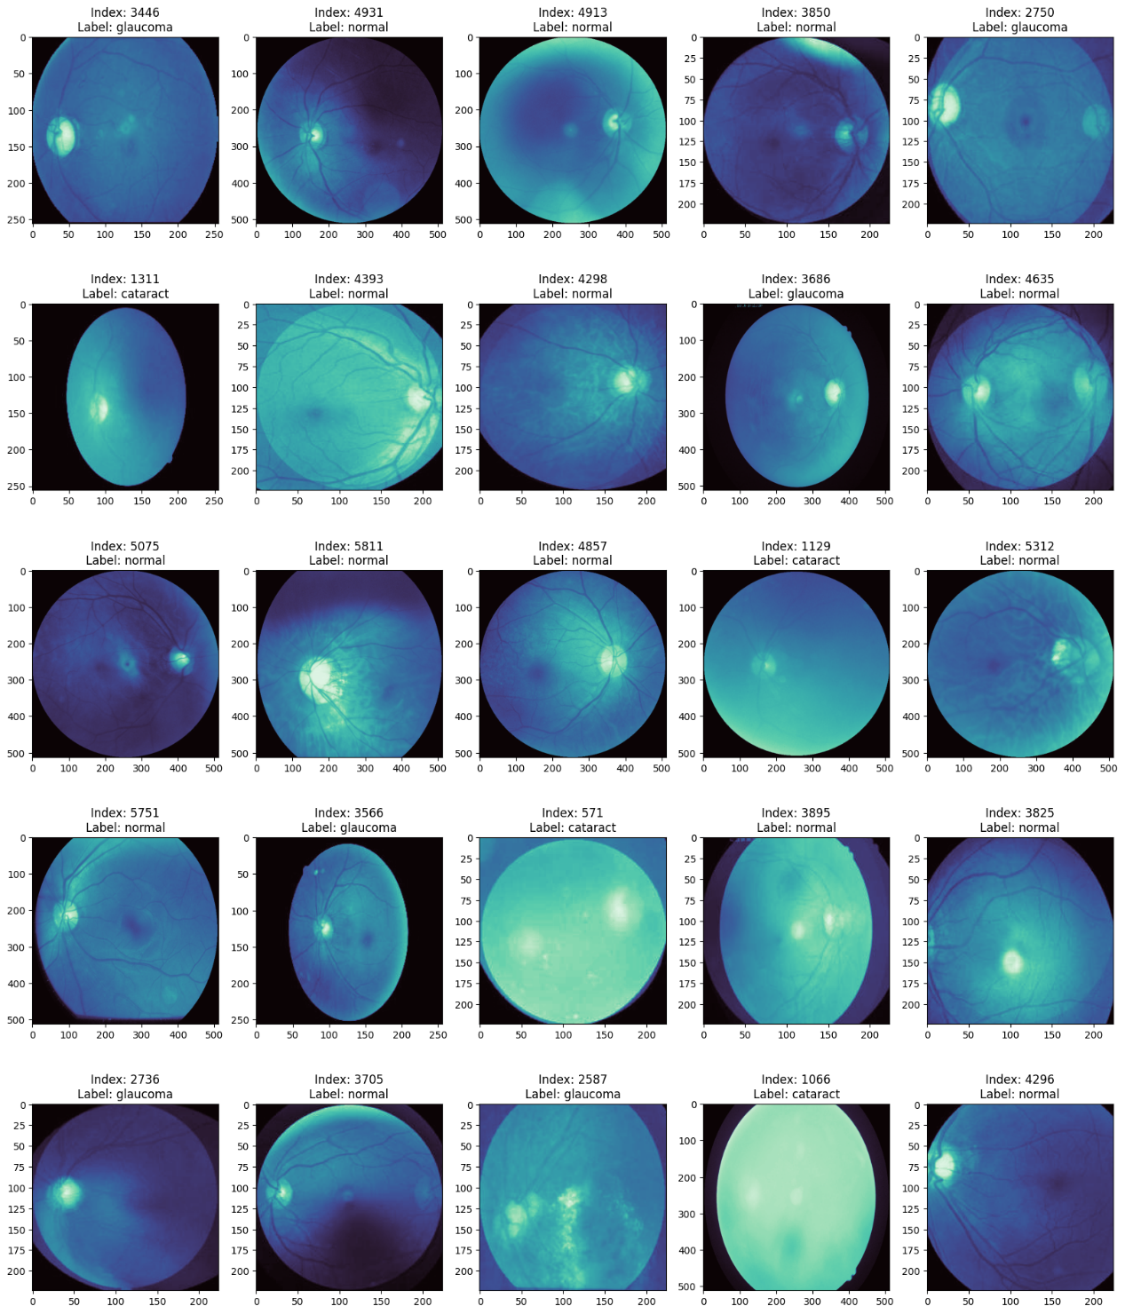

Eyes (Elastic Transformation)


Eyes(Noise injection)

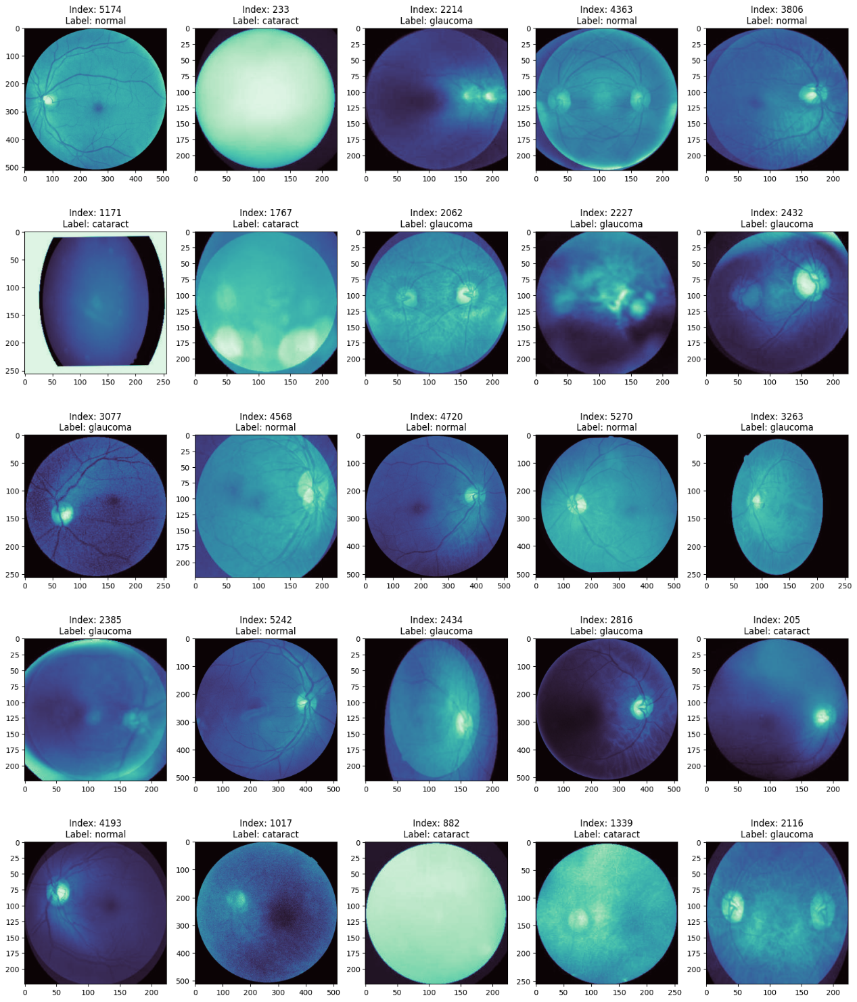
Eyes(Salfmix)

